Alicia Pons-Palacios

In January of 2007, a lady by the name of Alicia Pons-Palacios came to see me in Guayaquil because she had malignant melanoma metastasis. Apparently in 1998 she developed a serious nose bleed where nasal cavity lesions were found and cauterized. A little while later, she developed another nose bleed and upon inspection, a tumor was discovered and she had to undergo massive nasal and mouth reconstruction to exercise the cancer and tumor. At this time a biopsy was performed, confirming the activity of the level of cancer. Alicia was then given high dose adjuvant interferon for a period of one year. In February 2005, she had a relapse, revealing a new tumor that infiltrated the nasal septum, the floor and roof of the mouth and neck and gland area, revealing also a blockage of the right nasal cavity. Once again she went through a major surgery to remove the cancer and the tumor. At this stage noticeable facial damage was being done to the nose and major trauma was being excised to the mouth, throat, and nasal cavities. A biopsy confirmed that it was an extremely aggressive malignant melanoma with discriminate fused cells and fused nuclei.
By the time Alicia Pons came to me, she had been greatly abused psychologically with fear tactics, toxic medications, dangerous surgeries and useless advice, and was now told that she did not have much time to live - she now had an advanced melanoma. At this stage, she had been fighting her cancer for 9 years and was not very hopeful about being cured.
After the second operation, the pathology was able to accurately identify the cancer as a thermoplastic subtype of melanoma, a highly active, high-grade melanoma that had a high propensity for local, regional relapse. Between 2005 and 2007 this lady was subjugated to radiation, so her immunity was low, had extreme anxiety, nervousness, lack of sleep, fearfulness, was somewhat dehydrated, had loads of toxins, fungi, and was basically preparing herself mentally to die, and was just looking for any time she could buy. I suggested that she come with her husband and family support and that she stay with me for one week so that I could explain the dangerous effects fear, anxiety, stress, and hopelessness had upon her immunity, glandular system, and hormones. She was told that without the elimination of these emotions and feelings she did not have much hope as the mind is more powerful than any medicine or diet I could ever give her.
Realizing how sensitive she was about the damage that had already been done to her face and how emotionally unstable she really was, I decided to use Cansema very sparingly so as not to cause any additional trauma of added low self esteem. I was very strict with the diet, raw vegetable juices, one every hour, no meat, dairy, sugar, salt, refined or processed foods of any kind – with exercise being done 5 minutes every hour, and drinking the first urine of each day in the morning.
I kept Alicia responsible for her emotional health, and treatment for her turned out to be very easy for me, as she was very consistent and faithful in fulfilling every detail of the diet. Because of the small amounts of Cansema I was using on the face and neck, I made Alicia eat Cansema three times a day. Later as she responded, specific fruit known for their cancer killing properties such as Graviola, Pineapples etc., were added to the diet along with Cansema Tonic III and vitamin / mineral supplementation.
Alicia Pons had a lot of cancer, but what was amazing about her case was that the Cansema became less activated as time went on, even though cancer was active.
Large doses of colloidal Silver and Vitamin C was prescribed, with an increase in the intake of oleander, and continued intake of Cansema Tonic. The gland under the right side of the jaw began to swell, and then the right nasal cavity began to fill up with fluid. After several weeks the gland then became fibrous and died. It was then decided to remove the gland as the body was trying to reject it and to remove the liquid from the nasal cavity at the same time. Gland and fluids were then tested in pathology to see what was going on. I flew to Cuenca the day of the operation, as Alicia had requested that I be present during the removal of the gland and sinovial fluids.
The gland came out completely encapsulated, but filled with a liquid. The nasal cavity was completely blocked and it was drained. The skin inside the nasal cavity was healthy, no spots, legions, or inflammation of any kind. Flesh had a health pink glow, capillaries were not enlarged or inflamed, basically a picture of good health.

I had taken with me some Hydronium (H₃O) and before the neck or nasal cavity was stitched up, I used a concentrated solution of H₃O and thoroughly washed the area to ensure that any free floating cancer cells would be killed.
To everyone’s surprise the pathological reports revealed that the encapsulated gland had 85% very active cancer, and so did the mucous from the nose. I am amazed that the body is so intelligent that it had the ability to pool cancer with Cansema and Cansema tonic without cavitating and basically achieving the same objective while being more user friendly. Presently, Alicia is still taking Cansema, the Cansema Tonic, a multi- vitamin, a mineral supplement, exerting and concentrating on being happy, and takes sun baths regularly. Her diet has been expanded to everything except sugar, processed and refined foods
Cancer is not detectable; Cansema is inactive, and the latest Pet Scan revealed no hot areas of cancer anywhere in the body. She reduced medication to a multi-vitamin and a table spoon of Tonic once a day.

Neville Solomon

See photographs below

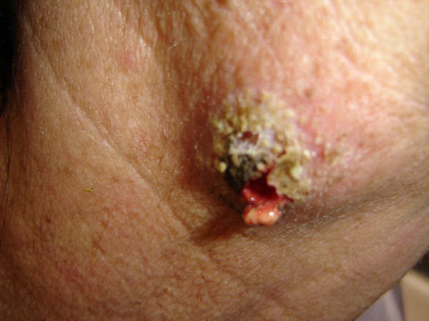
Photograph #1

Photograph #2
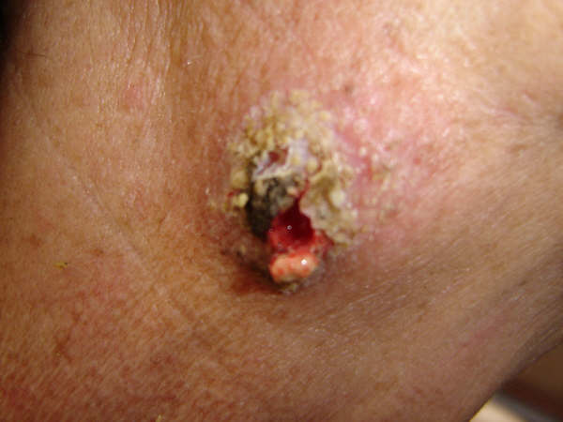

Photograph #3
