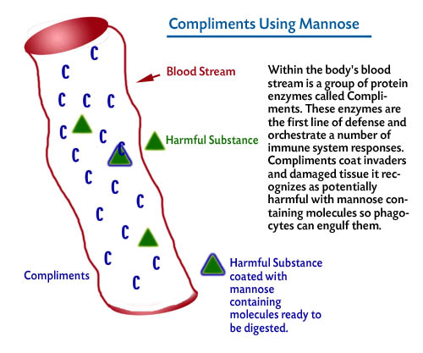

All Rights Reserved AL Low & Associates, Inc. ©

