Cansema Case #072308B – written by Neville G. Solomon, Ph.D.,
Guayaquil, Ecuador – name of patient withheld at her request.

- CANSEMA is an escharotic. Many documents state that CANSEMA is only good for skin cancers, primarily basal cell (BCC) and squamous cell (SCC) carcinomas, and melanomas. Greg Caton, the creator of both the product and the Alpha Omega Labs website that sells the product, has taken this position to minimize flack from the medicine community. However, experienced practitioners should know that this limitation on application is not at all true. As one example, I present the pictorial below, which shows the effectiveness of Cansema on a deep tissue cancer – a Stage IV breast cancer case. It is provided to show the effectiveness of Cansema in even severe cases.

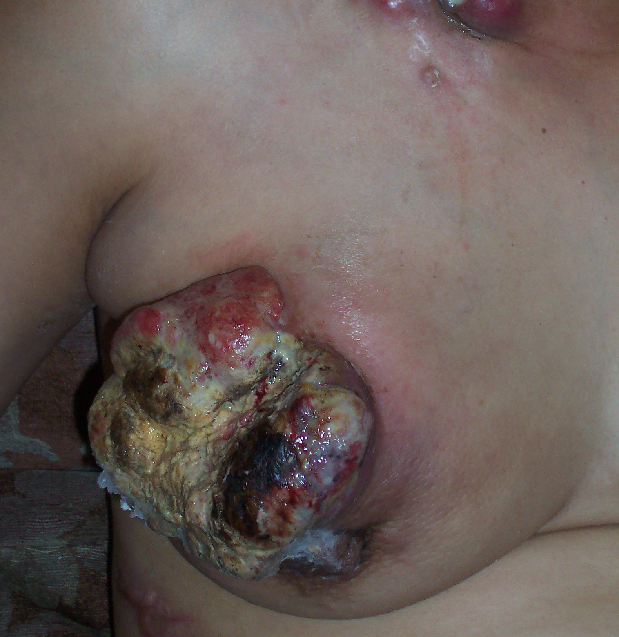

- CANSEMA also has the ability to work on very large or small tumors. The miracle of the product is that it will kill cancer cells, while normal, healthy cells will only are left alone. Upon killing those cancer cells in which it has come into direct contact (and even beyond, because of its penetrating ability), a scab or "eschar" is formed. If analyzed, the eschar will be found to contain not only the dead cancer cells, but also some of the body's own antibodies, macrophages, red blood cells -- the same kind of cellular debris one will find in almost any healing scab formation.

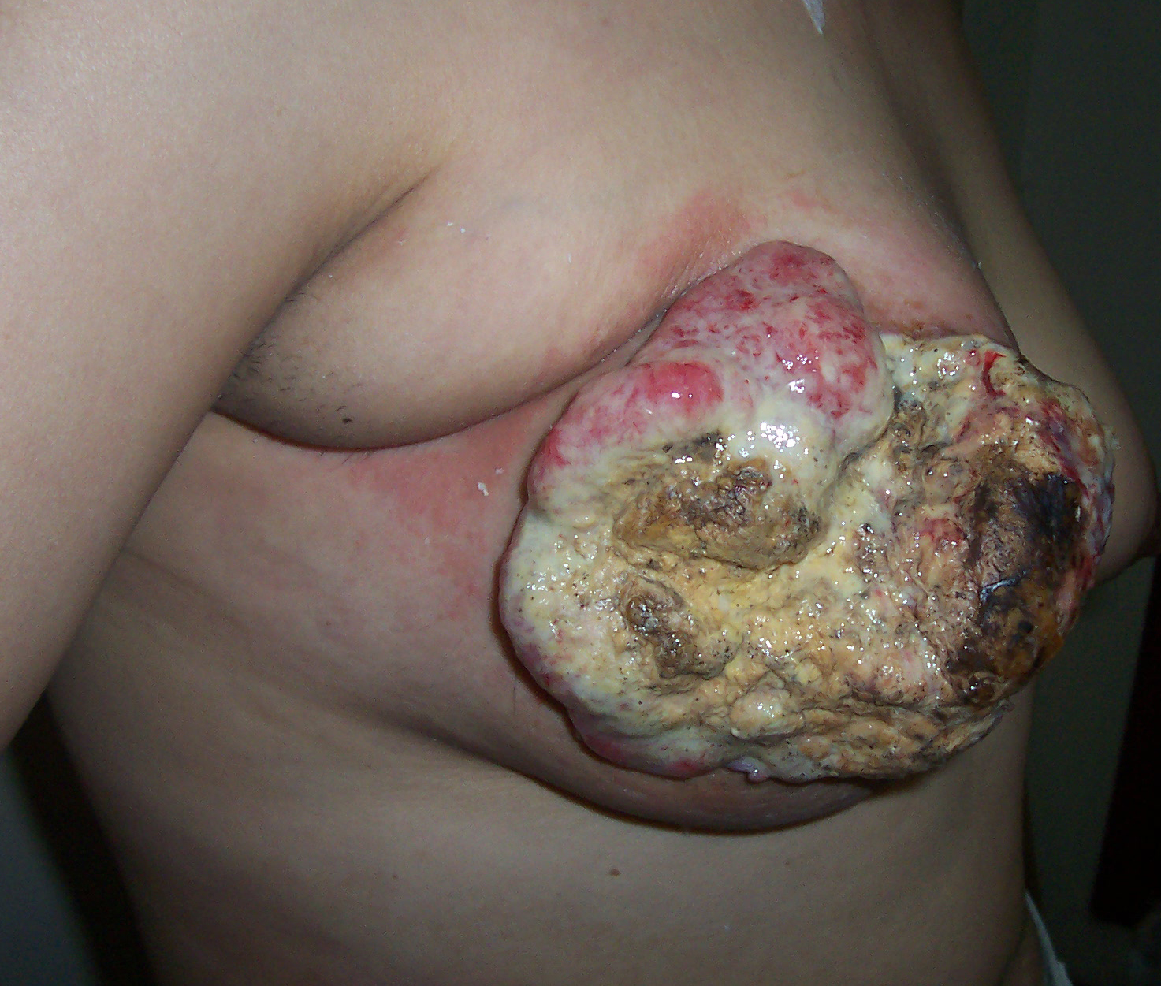

- When working with a large tumor or a metastasis, the golden rule is don't go too quickly. Avoid all sugars, milk and diary products, alcohol, meat, refined and process food as this lowers the body’s immulogical system. Be calm, don’t fear, try to make yourself happy as this helps the body to produce opiates and neuropeptides.
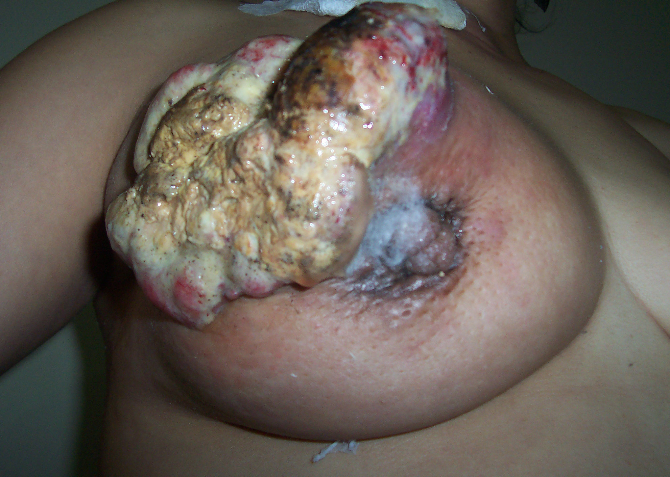

- Be consistent, stick with one diet that you know works, and don't flip-flop from one new cancer craze to another. When the ESCHAR turns white, it is an indication that that area of the tumor is dead. There should be no smell as that is an indication of infection. White necrotic tissue can be peeled off without pain.

…. Continue to page 2 of 2 ----- >

