Eschars Are
Temporary:

A Summary of the Pictorial History
of a Breast Cancer Patient
Using Cansema Black Salve

Introduction

Since you are looking at this presentation, there is a high likelihood that either you or someone you care about has recently become a breast cancer patient. I am not an expert in escharotic preparations, which are widely known as “black salves.” I am like you; I am just a breast cancer patient who has already been there —-a few steps ahead of you.
After I discovered a lump in my breast on October 17 of 2013, I was referred by my gynecologist the following week for a biopsy, which was scheduled on Friday, November 1. Fortunately for me, I had already been seeing an integrative doctor, so when I received the diagnosis of invasive ductal carcinoma of the right breast on Monday, November 4, 2013, I notified him right away. He immediately introduced me to an immune system treatment that is not limited to cancer, but is used for treating a lot of cancers. (www.GcMAF.eu)
I had also been referred by the gynecologist for a visit with a breast surgeon for what was called a “conference on the pathology report.” It was really an attempt to sell the whole conventional line of treatment.
The surgeon said she was going to present my “options” for treatment. The three “options” were (1) bilateral mastectomy (2) mastectomy of only the affected breast, (3) what she called “breast-conserving lumpectomy.” I think they try to scare you with the worst options first, so by the time they get to the third one, (they hope) you will say, “That sounds like the least scary one; sign me up for that one.” The surgeon scared the daylights out of me with her description of the “breast conserving lumpectomy,” in which she proposed to cut off about half of my breast, which sounded pretty radical to me, and then she would send me for other treatments to follow.
I flat-out turned down chemo and radiation, and would not commit myself to the surgery. I started as soon as possible with the Macrophage Activation Factor treatments, but I still kept looking for ways to supplement that treatment because the GcMAF people also recommended surgery, and I was looking for any possible way to escape the surgery.
I read piles of books, web sites, medical journal articles, and whatever I could get my hands on. I think I was near the point of driving my poor doctor nuts because I was always researching something and bringing him stuff to read and discuss. He was incredibly patient with me. He never told me I had to have surgery, but every time he mentioned that the GcMAF people recommend surgery in conjunction with the MAF treatment, I went off and researched something else and something else.
I kept praying for the answer that would help me to avoid dismembering surgery. I had come across things about black salve before, but it was in relation to skin cancer. At that time, I did not know that there was a deep-tissue version of the salve that was also good for breast cancer.
One of the books I had read was Bill Henderson’s Cancer-Free, and I had signed up for his mailing list. In some of his e-mails he was promoting a conference about natural cures for cancer. I could not attend the conference, but a few weeks after the conference was over, his e-mails gave some reviews of the conference. In one little video Chris Wark (http://www.ChrisBeatCancer.com/) was interviewing Dr. Veronique Desauliniers who had run a holistic health center and treated other people for a lot of health issues, including breast cancer, and then she got breast cancer herself. One of the things she talked about using for herself was black salve, sometimes called “botanical surgery.”
I was immediately riveted, and felt like this was the revelation I had been searching for. I ordered her book, Heal Breast Cancer Naturally, and started researching everything I could find on the internet regarding black salve for cancer treatment. The rest is history.
From the time I started using escharotic salve, up to the time I finished my picture collection, I took pictures nearly every day to send to both the naturopath from the salve company, Alpha Omega Labs (www.altcancer.com), and my local integrative doctor. By now I have hundreds of pictures, showing nearly every detail of the process from beginning to end. Included here is only a comparatively brief representative cross section of the whole collection of pictures so you can get an overview of the process without having to wade through hundreds of pictures.
The pictures are not professional photography. They were done with a cell phone camera, e-mail, and two photo editing programs. Many of the pictures originally came out too dark, too purple, too this, or too that. I used the photo editing programs to correct the color as much as possible; as well as to crop the pictures to focus on whatever was the main subject of that picture. A third photo editing program was added later, as I was working on this picture book, and had some difficult editing problems. Since color correction is not perfect, sometimes you will see two pictures of nearly the same thing, and the color is a little different. To guess which ones are as close to the right color as possible, look at the pic-tures before and after the one you have a question about, and it will probably help you to figure out.
If salve is your choice to replace surgery, I do not in any way suggest that your configuration or number of eschars will be like mine. In fact, it may be drastically different. Eschars are like snowflakes. All of them are different, but their basic characteristics are all the same. What I hope you can glean from this presentation is the basic characteristics of eschars, and a knowledge of approximately what to expect so you will have a good idea where you are going with escharotic salve.
For mass communication purposes, my name has been withheld, but I am the patient behind the pictures. The owners of the copyright for this presentation are the owners of Alpha Omega Labs of Guayaquil, Ecuador, and an integrative medicine clinic where I was already a patient prior to my cancer diagnosis. They are intimately familiar with my case, as they have watched it unfold from day to day. They can verify anything that I have stated.
I hope you will be as blessed as I have been through the use of Cansema escharotic salve for the treatment of breast cancer, skin cancer, or any other condition that is amenable to the use of this salve.

The Escharotic Process: What Happens After the Application of Salve
- The first thing that can happen is NOTHING. If you are not sure whether you have cancer in a certain area, and you apply salve for a few days, but nothing happens, or maybe you get only a little redness of the skin, then you probably have not applied salve in the right place.
- If the salve starts to cause a reaction, the first thing that happens will be what I call “peach fuzz,” a stage in which the pores are being opened up for the salve to penetrate, and the skin surface looks like yellow velvet or peach fuzz.
- After that, you will see small ulcerations in the skin, which are necessary in order to allow the salve to get inside and do its job. These little ulcerations in the skin will have yellow rings around them. The rings are just little bits of epidermal tissue, and they eventually will dry up and fall off.
- Then the centers of these circles turn black, or at least dark reddish brown. This is an eschar surface.
- The eschars continue to grow in size and number.
- One thing that can happen is that several eschar surfaces will form where the cancer underneath is minimal. There will be nothing but a few thin eschar surfaces, which will eventually just come loose and fall off with little or no debris attached to the back.
- The other thing that happens where there is a more sizeable pocket of cancer cells is that many small individual eschars coalesce into an eschar mass that grows until it has covered the “hot spot” that has cancer under it. Different eschar masses may be many different sizes and shapes, as the eschar growth follows the path of the cancer cells that are inside.
- The eschars are maturing. While the Cansema Salve works on the inside, killing cancer cells and dragging them to the surface, the dead cancer cells and immune system debris become attached to the back of the eschar surface.
- When they have served their purpose, the eschars gradually separate from the surrounding skin tissue. The edge of the skin gradually heals as it separates from the eschar a little bit at a time.
- As the eschar separates, you will get seepage of fluid from behind the eschar mass. At this point, bandages are needed until separation, ejection, and healing are complete.
- When the eschar has separated all the way around, as well as underneath, one day you take off the bandage, and the eschar will just fall out with a pocket of debris attached to the back. Your body has just spit out a pocket of cancer. There is rarely, if ever, any bleeding because of the amount of healing that has already taken place under and around the eschar.
- The last thing that happens is that the body works on filling in the hole or “decavitation” with new tissue. The body manufactures little pieces of white tissue that look like tiny sheets of onion skin paper. I sometimes call it “wallboard tape.” It patches the holes or seams until the body can finish filling in the hole behind the tape.

Note about picture numbers: Below or beside each picture is first the date. All dates are 2014. After the date is a series of numbers, which are just the time in 24 hour format, as given by the cell phone camera program. For example, 13:02:54 means the picture was taken 54 seconds after 1:02 p.m. Most of the time, you may not care what time the picture was taken, but in some cases, you may want to know whether a certain picture with the same date was taken 2 minutes after the previous one, or maybe 14 or 16 hours later. The numbers not only serve to identify each picture, but to help you determine the amount of time lapse between pictures.
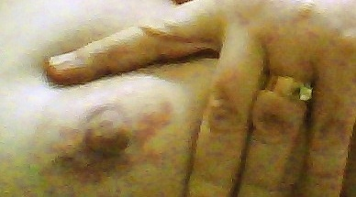 |  |  |  |  |  |  |  |  |  |  |  |  |  |  |  |  |  |  |  |  |  |  |  |  |  |  |  |  |  | 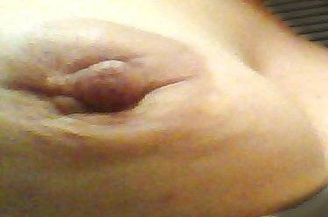
April 21, 11:51:00.
This picture is included here for comparison.
It was taken April 21, seven weeks before I started using salve. The line of slightly red to yellow discoloration in the picture above is due to the use of topical iodine. In late January, an ultrasound scan had shown a second tumor spot just below the first one. You can see the two spots above, but they are still quite small. |  |  |  |  |  |  |  |  |  |  |  |  |  |  |  |  |  |  |  |  |  |  |  |  |  |  |  |  |  |  |  |  |  |  |  |  |  |  |  | June 9, 2014, 02:56:00. This is just before applying salve for the first time. Here you can see an increase in the size of the tumor spots, a deep valley be-tween them, and much more inversion of the nipple, compared to April.
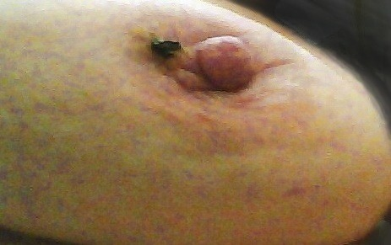 |  |  |  |  |  |  |  |  |  |  |  |  |  |  |  |  |  |  |  |  |  |  |  |  |  | 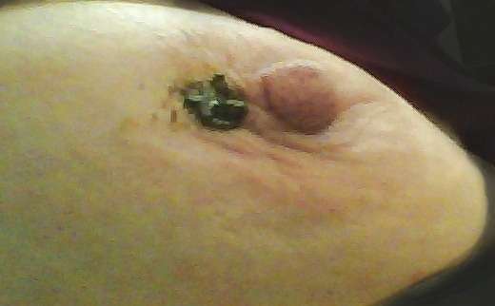
June 9, 03:05:21. First salve application. I was first advised to use a very tiny spot of salve only about as big as the eraser end of a pencil. Different people will have widely varying responses to the application of salve. |  |  |  |  |  |  |  |  |  |  |  |  |  |  |  |  |  |  |  |  |  |  |  |  |  |  |  |  |  |  |  |  |  |  |  |  |  |  |  |  |  | June 10, 01:58:29. By the next day, nothing had happened, so I was advised to increase the amount of the salve.
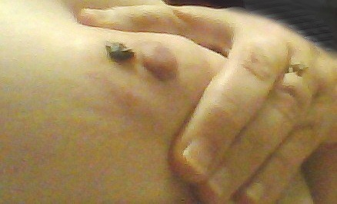 |  |  |  |  |  |  |  |  |  |  |  |  |  |  |  |  |  |  |  |  |  |  |  |  |  |  |  |  |  |  |  |  |  | 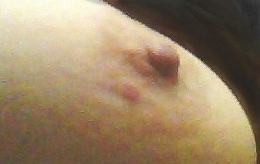
June 10, 17:32:46. By the next evening, I had a very tiny red spot on the edge of the areola, not very close to the tumor spots. |  |  |  |  |  |  |  |  |  |  |  |  |  |  |  | June 11, 11:42:34. The faint beginning of escharization. By the next night, the first little spot was getting bigger and a little more red. I kept applying salve every night.
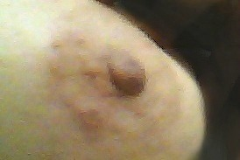 |  |  |  |  |  |  |  |  |  |  |  |  |  |  | 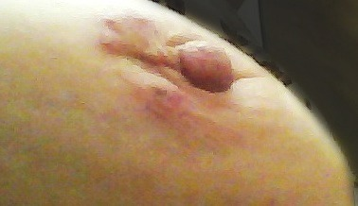
June 12, 15:00:23. By the next night, I had 4 little red spots. Because the salve had been covered by a band-aid, it had spread out to the edges of the gauze on the band-aid, thus causing reactions that were on the edge of the areola instead of being next to the tumor spots. |  |  |  |  |  |  |  |  |  |  |  |  |  |  |  |  |  |  |  |  |  |  |  |  |  |  |  |  |  |  |  |  |  |  |  |  |  |  |  | June 14, 00.25.37. 4 spots, but all on the periphery of the areola, not next to the tumor spots. The first one is begin-ning to turn dark in the middle, getting ready to form an eschar.
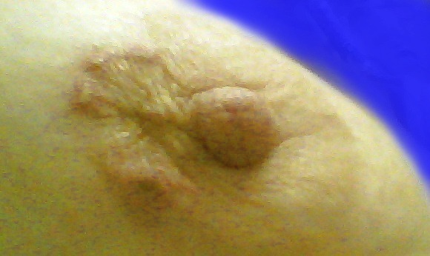 |  |  |  |  |  |  |  |  |  |  |  |  |  |  |  |  |  |  |  |  |  | 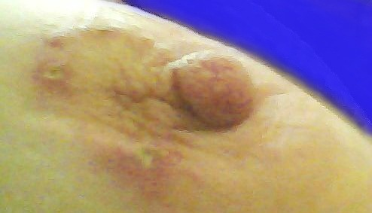
June 14, 13:36:15. |  |  |  | June 15, 23:26:50. More tiny spots are forming, and the ones that were there are opening up, getting ready to form eschars.
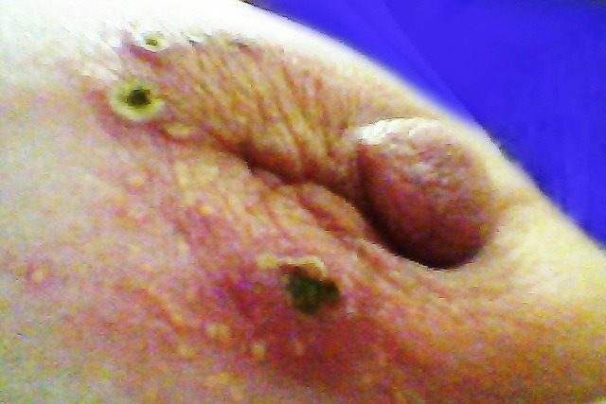 |  |  |  |  |  |  |  |  |  |  |  |  |  |  |  |  |  |  |  |  |  | 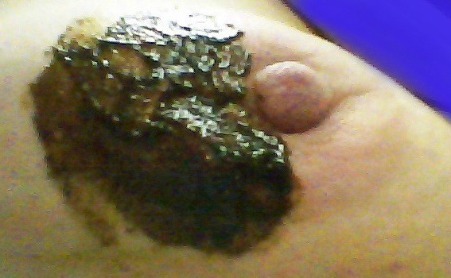
June 16, 23:57:59. New tiny little pin-prick eschars developing all around the areola, and the first ones have bigger black centers. |  | June 17, 12:02:13. Here, I was instructed to use salve over a wider area, but to dilute it with coconut oil to make it more gentle on the skin. This is what I did the rest of the time that I used salve. Do NOT try this with full-strength salve. If you do, you may have such a burning response that you cannot stand the pain.
Don’t let salve touch the nipple. Every woman knows the nipple is the most sensitive part of the breast. When applying salve, I knew to avoid direct contact with the nipple, but one night it happened by accident that I put a bandage over the salve, and the salve spread out over part of the nipple. It became hot and painful, and I had to alternately use moisturizing lotion and coconut oil on the nipple for a couple of days to counteract the effect.
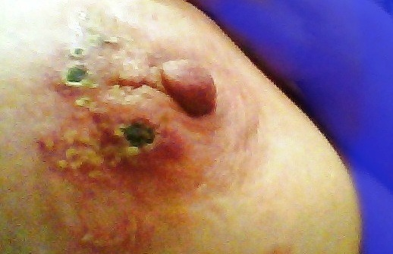 |  |  |  |  |  |  |  |  |  |  |  |  |  |  |  |  |  |  |  |  |  |  |  |  | 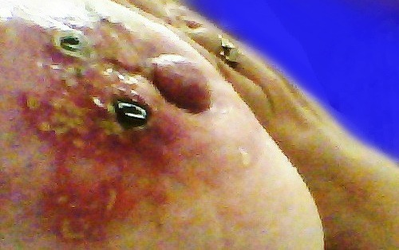
June 18, 23:51:56. Now there is a cluster of tiny eschars at the far edge of the areola, next to the big one on the side. |  |  |  |  |  |  |  |  |  |  |  |  |  |  |  |  |  |  | June 19, 22:52:39. More new eschars in response to salve. This time they are outside the areola. See lower left corner of picture above.
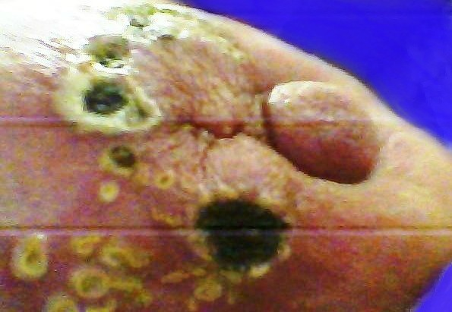 |  |  |  |  |  |  |  |  |  |  |  |  |  |  |  |  |  |  |  | 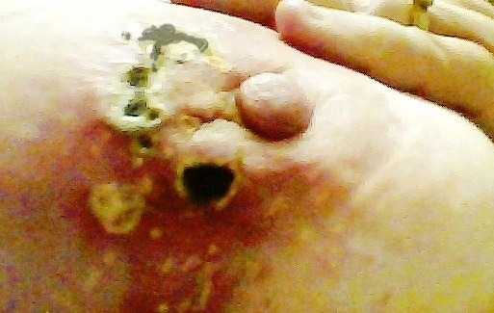
June 20, 22:15:59 |  |  |  |  |  |  |  |  |  |  |  |  |  |  |  |  |  |  |  | June 21, 22:09:29
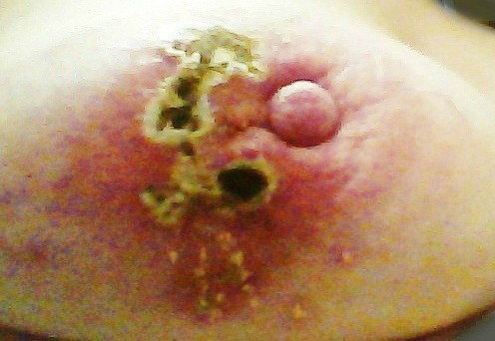 |  |  |  |  |  |  |  |  |  |  |  |  |  |  |  |  |  |  |  |  |  |  |  |  |  |  |  |  |  |  |  | 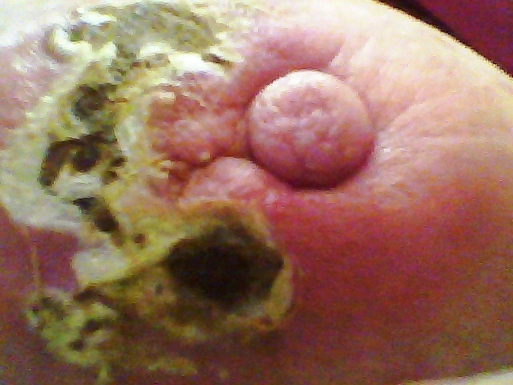
June 22, 23:04:45 |  |  |  |  |  |  |  |  |  |  |  |  |  |  |  |  |  |  |  |  |  |  |  |  |  |  |  |  |  |  |  | June 23, 22:37:46
By this time, multiple eschars have coalesced into one eschar mass, and the mass just keeps growing, but never covers the tumor spots next to the nipple.
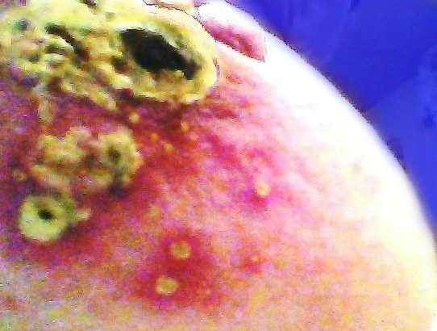 |  |  |  |  |  |  |  |  |  |  |  |  |  |  |  |  |  |  | 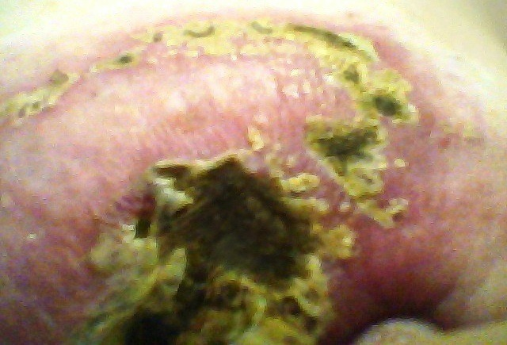
June 24, 23:09:13. This close-up picture is approximately the lower one-third of the eschar mass in the frame below. The edges around the eschars are composed of epidermal tissue, which will eventually dry up and fall off. |  |  |  |  |  |  |  |  |  |  |  |  |  |  |  |  |  |  |  |  |  |  |  |  |  |  |  |  |  |  |  |  |  |  |  |  |  |  |  |  |  |  |  |  |  | June 24, 23:11:27. Escharization is expanding both above and below what was already there.
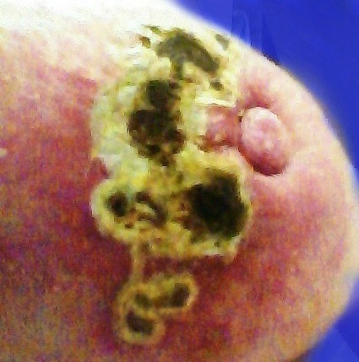 |  |  |  |  |  |  |  | 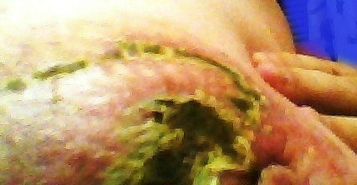
 |  |  |  |  |  |  |  | (Left) June 25, 23:46:37. Main eschar mass. (Above) June 25, 23:41:11. A string of eschars has been forming around approx. 1/3 of the periphery of the breast.
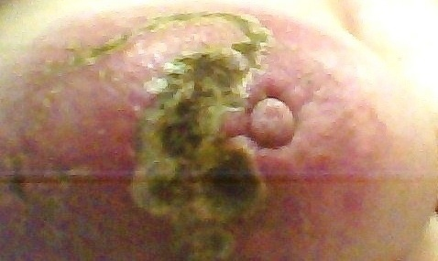 |  |  |  |  |  |  |  |  |  |  |  |  |  |  |  |  |  |  |  |  |  |  |  |  |  |  |  |  |  |  |  |  |  |  |  |  |  | 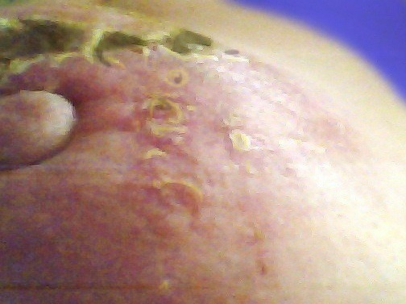
June 27, 00:06:14 |  |  |  |  |  |  |  |  |  |  |  |  |  |  |  |  |  |  |  |  |  |  |  |  |  |  |  |  |  |  |  |  |  |  |  |  |  | June 27, 00:07:35.
Notice the slightly dark shadowy area forming a semi-circle on the opposite side from the eschar mass in both pictures above. This slightly deeper pigmentation happened first, and then was fol-lowed by the beginning of escharization along this pathway. Even though the second picture above was taken little more than a minute after the first one, at this point you need the benefit of the more close-up picture on the right to see to see what is happening. Even though I had not yet used salve on this side of the nipple, the influence of the salve had spread through the tissues.
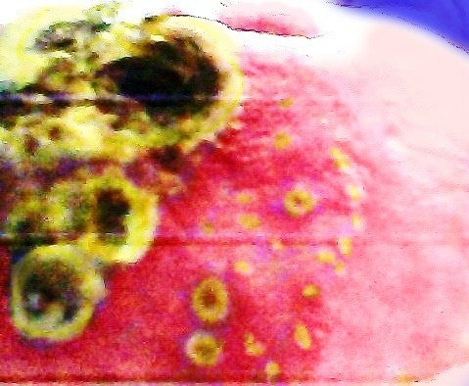 |  |  |  |  |  |  |  |  | 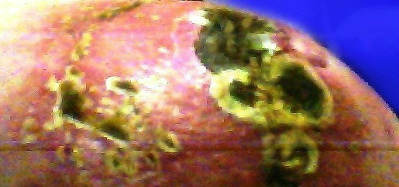  June 27, 02:31:04. The picture on the left is a close-up version of the same area that is the lower part of the picture above.
June 27, 00:07:59. Eschars themselves do not hurt, but when there is an intense battle going on inside the breast, it becomes sore and painful. As you might guess from the pictures, the week of approx. June 24 to June 30 was the most painful time, and June 26 was the worst day I had with swelling, pain, feverishness of the affected breast, and reddish purple color. (No matter which of the pictures on this page is closer to the correct color, one thing that is certain is that the skin color at that time was very intense because of swelling and a high degee of inflammation due to the battle going on inside.) I skipped using salve for the next two days, and had to use strong pain medicine for several days to a week. Then the peak of escharotic activity passed, and the pain and soreness started subsiding as the main eschar mass began separating from the tissue around it, and progressed toward ejection.
 |  |  |  |  |  |  |  |  |  |  | 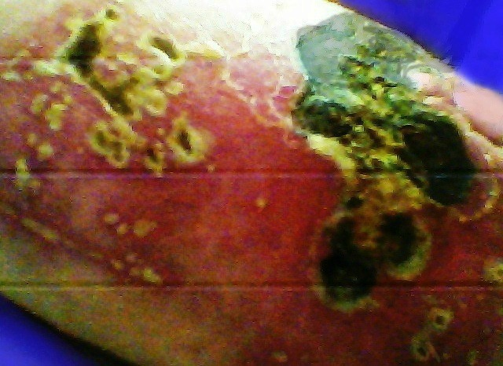
June 28, 00:32:00. The center seam of my bra could not meet the center of my chest because of the swelling in the affected breast. |  |  |  |  |  |  |  |  |  |  |  |  |  |  |  |  |  |  |  |  |  |  |  |  |  |  |  |  |  |  |  |  |  |  |  |  |  |  |  |  |  |  |  |  | June 28, 00:34:12. Here is what it looked like inside that bra.
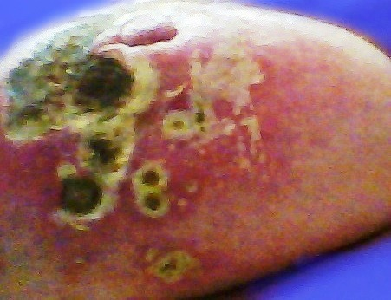 |  |  |  |  |  |  |  |  |  |  |  |  |  |  |  |  |  |  |  |  |  |  |  |  |  |  |  |  | June 29, 22:39:34. The main eschar mass is well formed with a hardened surface by now, covering most of that side of the breast except the little tumor spots next to the nipple. After a couple days’ break from salve, I started using salve again on the night of June 28, but on the opposite side of the breast. In the lower part on the right side of the picture, besides the well-formed small eschars, you can also see the “peach fuzz” stage of new escharization closer to the nipple.
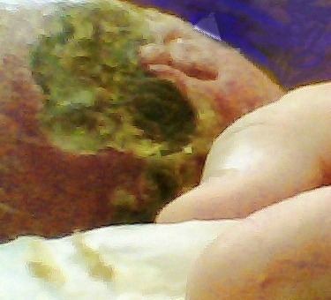 |  |  |  |  |  |  |  |  |  |  |  |  |  |  |  |  |  |  |  |  |  |  |  | June 29, 22:41:48. (Left) Notice the yellow to gray material on the tissue over my finger. The fringe around most of the eschars in the last several pages is just epidermal cells that are displaced by the newly forming eschar. The fringe edges may look dramatic for a while, but they fall off and go away.
 |  |  |  |  |  |  |  |  |  |  |  |  |  |  |  |  |  |  |  |  |  |  |  | 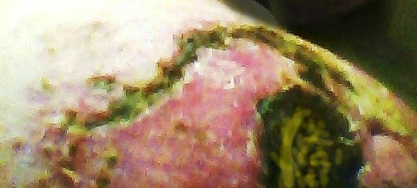
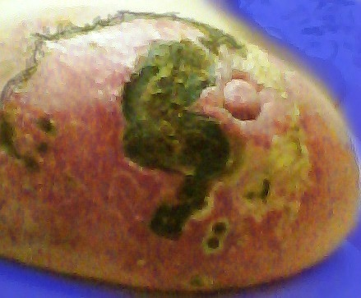 |  |  |  |  |  |  |  |  |  |  |  |  |  |  |  |  |  |  |  |  |  |  |  | June 30, 22:26:44. (Above) The string of eschars around the outside edge is an example of how the salve ”knows” where to go to follow the path of the cancer cells. These eschars are well entrenched. The yellow surface on the other side shows the increase of escharotic activity there.
 |  |  |  |  |  |  |  |  |  |  |  |  |  |  |  |  |  |  |  |  |  |  |  | 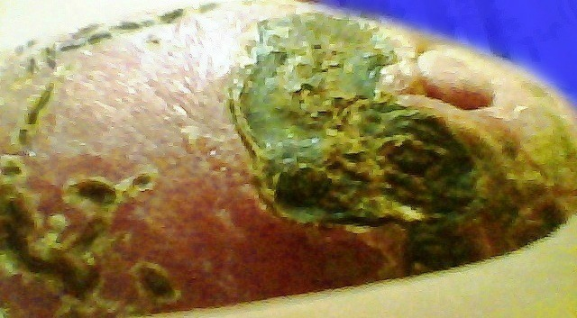
June 30, 22:25:32. A better view of the yellow “peach fuzz” on the right side of the picture — the beginning of response to salve. |  |  |  |  |  | July 1, 23:11:07. The main eschar mass is chipping and cracking, and just beginning to separate a little bit from the tissue around it. Escharization is also beginning to spread all around the other side, and encircle the nipple.
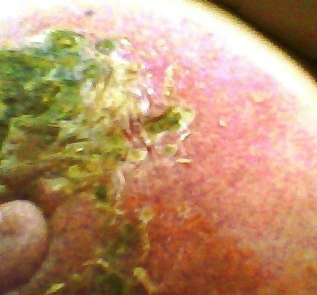 |  |  |  |  |  | Do even cancer cells have some strange sense of humor, that instead of making a line and coming to an unceremonious halt, they make a curved line around the peripery of the breast, and end with a decorative fancy little curlicue?
 |  |  |  |  |  | Due to a cell phone malfunction, I have no pictures from July 2 and 3. The eschar mass, both above the nipple, and on the right side of the picture, was continuing to form during that time. On July 3 the older part of the eschar mass above the nipple began to crack and split into sections.
 |  |  |  |  |  | Also on July 3, it felt like the cloud of fatugue that had been hanging over me lifted. Of course I still got tired and took afternoon naps, but the cloud of intense fatigue was gone. I theorize that even though no eschars had been ejected yet, I may have reached a point where enough cancer cells had been killed that it was a turning point in my recovery
July 1, 23:10:47. Continued development of the eschar mass both above and beside the nipple.
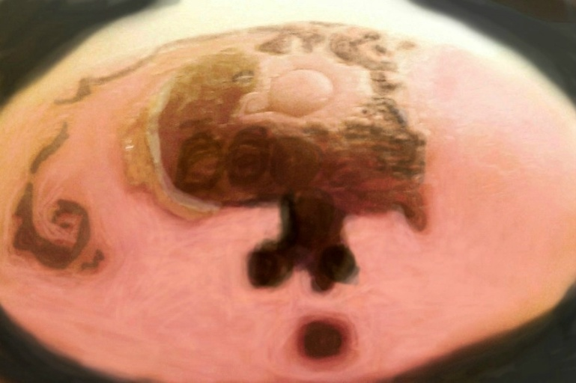 |  |  |  |  |  |  |  |  |  |  |  |  |  |  |  |  |  |  |  |  |  |  |  |  |  |  |  |  |  |  |  |  |  |  | 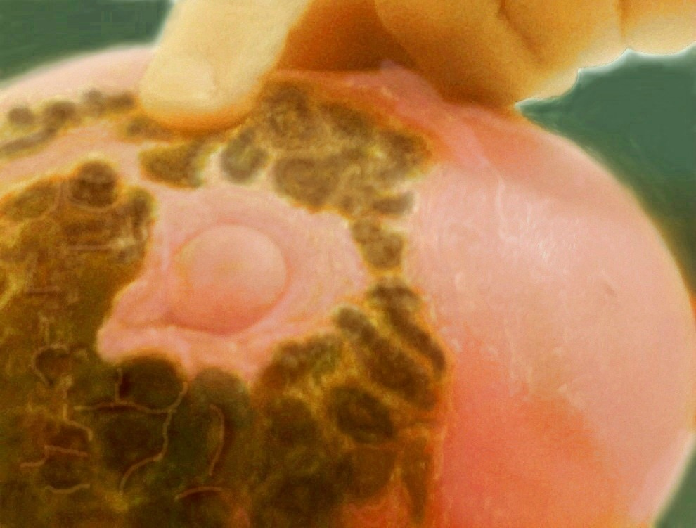
July 4, 16:37:23 The picture above shows a significant amount of separation of the main eschar mass from the tissue on the left side of the picture. The eschar edges are starting to turn gray. At this point, seepage of fluid from under the eschar is mild because the separation is only surficial. |  |  |  |  |  |  |  |  |  |  |  |  |  |  |  |  |  | July 4, 16:40:45. Above the nipple, the cracks between sections of the eschars are getting bigger. The eschar mass is also beginning to crack on the right side of the picture. The circular eschar mass was stiff and felt like a coat of armor, so signs of cracking and crumbling were a welcome development.
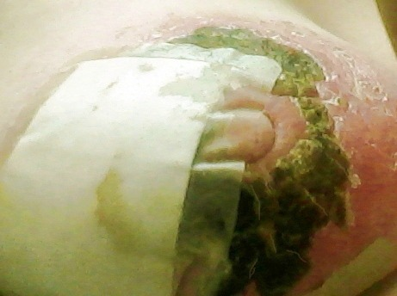 |  |  |  |  |  |  |  |  |  |  |  |  |  | 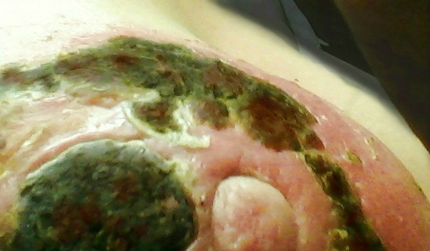
July 5, 23:52:14. In the last couple days, I have been having to use bandages because of the seepage caused by the increasing separation of the main eschar mass. | July 5, 23:55:10. The crack above the main eschar mass looks like a painful crack in the skin, but it isn’t. It is a significant amount of separation of the main eschar mass from the tissue around it. The edge of the skin gradually heals and separates from the eschar mass, and then heals and separates some more. The result is not pain, but seepage of fluid from under the pocket of debris attached to the eschar mass. It actually seems to help relieve some of the pressure inside.
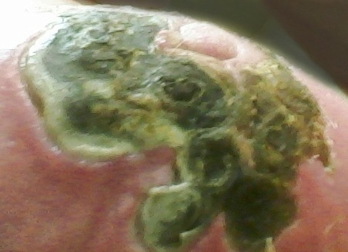 |  |  |  |  |  |  |  |  |  |  |  |  |  | July 5, 23:56:03. Notice the increasing width of the yellow-gray edge around the eschar mass on the left side of the picture, and the continuation of separation from the skin tissue around it. Also, on the right side of the picture, notice that the eschar mass has a different texture, is crumbling, and has no gray edge around it.
July 5, 23:58:47. More cracking and crumbling on the right side of the picture. This eschar mass is not as firmly entrenched as the one on the other side, and does not have such a big pocket of cancer behind it. |  |  |  |  |  |  |  |  |  |  |  |  |  |  |  |  |  |  |  |  |  |  |  |  |  | 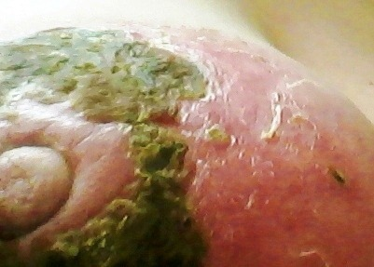
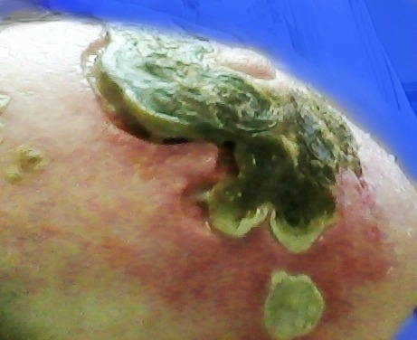 |  |  |  |  |  |  |  |  |  |  |  |  |  |  |  |  |  |  |  |  |  |  |  |  |  | 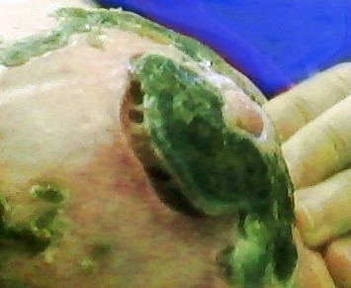
July 7, 15:23:14. More and more separation. This stage is requiring more and more bandaging because of the increased flow of sticky fluid from under the eschar mass. Notice that around the bottom part of the eschar mass where there has not been much separation yet, the skin color is still much more intensely red than on the side, where there has been a lot of separation. |  |  |  |  |  |  |  |  |  |  |  |  |  |  |  |  |  |  |  |  |  |  |  |  |  |  |  |  |  |  |  |  |  |  |  |  |  |  | July 8, 11:52:54. In this picture, I am coming unglued. This eschar surface is very thick and hard. Also notice the much lighter skin color at the bottom of the eschar mass (compared to the picture on the left), since significant separation has reduced the amount of pressure and inflammation.
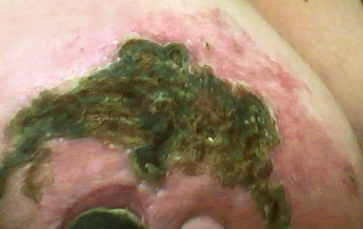 |  |  |  |  |  |  |  |  |  |  |  |  |  |  |  |  |  |  |  |  |  |  | 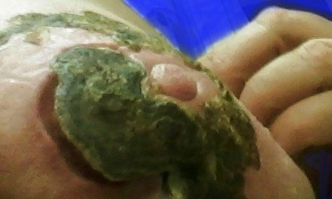
July 8, 23:33:19. A large eschar mass, like the one at the bottom of this picture, may shrink as it separates. |  |  |  |  |  |  | July 8, 23:33:07. There is separation around the top, the outer edge, and part of the bottom section of this eschar, but not on the side toward the nipple, where the tumor spots are.
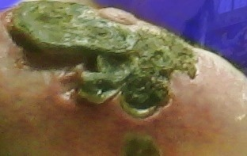 |  |  |  |  |  |  |  |  |  |  |  |  |  |  |  |  |  |  |  |  |  |  |  |  |  |  |  |  |  |  | 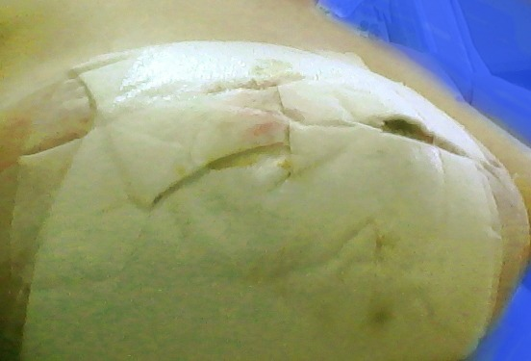
July 9, 00:10:23. As separation has spread around the bottom part of the main eschar mass, redness and inflammation in that area have decreased. Seepage is very intense and requires all-over bandages. |  |  |  |  |  |  |  |  |  |  |  |  |  |  |  |  |  |  |  |  |  |  |  |  |  |  |  |  |  |  | July 11, 10:28:01. Two non-stick bandage pads have been on overnight. If you have seepage around a separating eschar, do not use plain gauze pads. If you do, you will have a very hard time getting them off.
 |  |  |  |  |  |  |  |  |  |  |  |  |  |  |  |  |  |  |  |  |  |  |  |  |  |  |  |  |  | 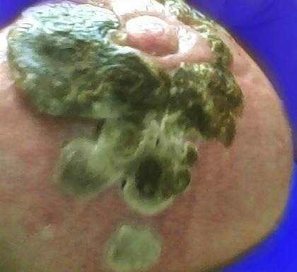
July 11, 01:23:56. By this time, pain and swelling have considerably decreased. Even though I still had some swelling, my bra fit normally, and the center seam lined up with the center of my chest.
 |  |  |  |  |  |  |  |  |  |  |  |  |  |  |  |  |  |  |  |  |  |  |  |  |  |  |  |  |  | July 11, 01:32:47. One strange little eschar at the bottom changes back and forth between slimy gray and black. The appendages above it are also deteriorating and turning gray.
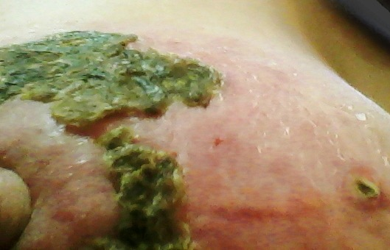 |  |  |  |  |  |  |  |  |  |  |  |  |  |  |  |  |  |  |  |  |  |  |  |  |  |  |  |  |  |  |  |  | 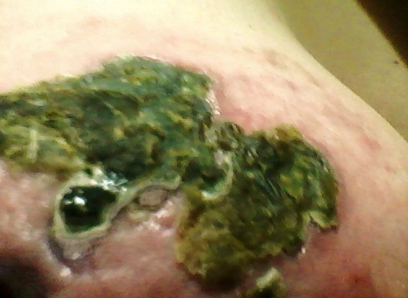
July 11, 10:32:39. By now, there is lots of cracking and splitting of the secondary eschar masses on both the side and the top. |  |  |  |  |  |  |  |  |  |  |  |  |  |  |  |  |  | July 12, 00:29:34. You can see deep holes, called “decavitations” in the skin under this eschar, where pockets of debris have been sucked out.
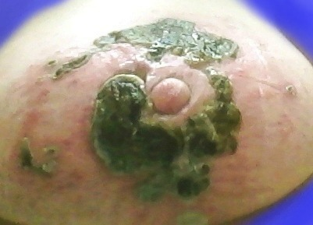 |  |  |  |  |  |  |  |  |  |  |  |  |  |  |  |  |  |  |  |  |  |  |  |  |  |  |  |  |  |  |  |  | 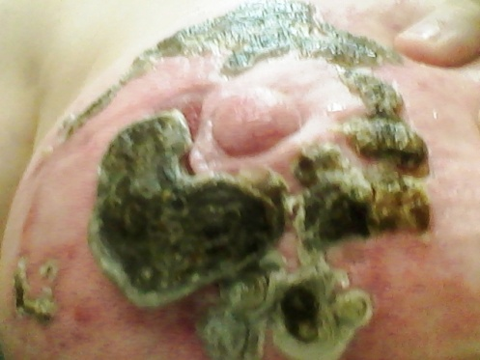
July 12, 00:14:13. Overview. The crescent-shaped eschar is detached at the top, on the side, and on the outer periphery, but is still attached near the two little tumor spots. |  |  | July 13, 23:29:10. The crescent-shaped eschar that formed beside and half way around the two little tumor spots has finally let go of that spot, and is SO-O O close to falling out, but is still hanging on right at the bottom, below where the tumor spots were. The eschar mass opposite the crescent is no longer just cracking; it is splitting apart into completely separate pieces. The appendages at the bottom are so deteriorated, it is a wonder they haven’t fallen off.
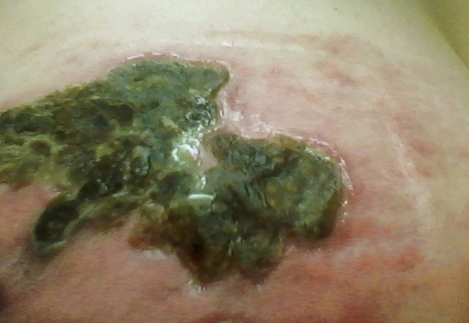 |  |  |  |  |  |  |  |  |  |  |  |  |  |  |  |  |  |  |  |  |  |  |  |  |  |  |  | 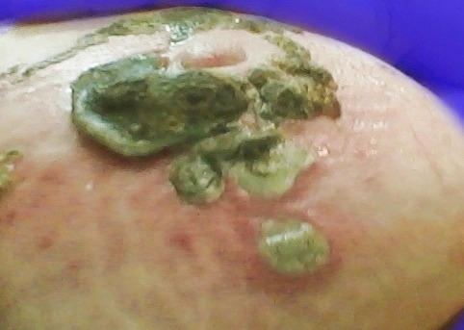
July 15, 01:57:50. The top eschar mass is also falling apart. |  |  |  |  |  |  |  |  |  |  |  |  |  |  |  |  |  | July 15, 01:58:04. The appendages at the bottom of the eschar mass are now so deteriorated that they are no longer recognizable.
July 15, 23:43:08. Late at night, I took off the bandage, and this is what happened. A huge pocket of cancer had just been spit out of my body—definitely worth some pain and swelling along the way as the salve fought a battle against cancer cells inside my breast !  Notice that where the two little tumor spots were next to the nipple, the material under them has been sucked away, and is now part of the ejected eschar mass! |  |  |  |  | 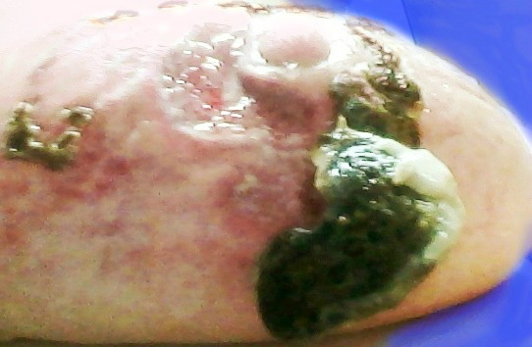
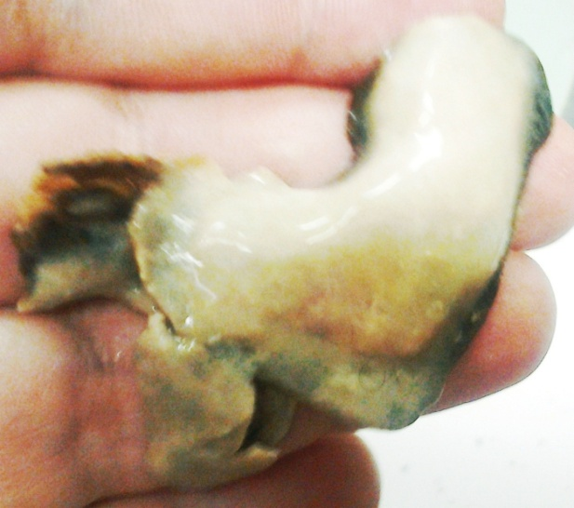 |  |  |  |  | 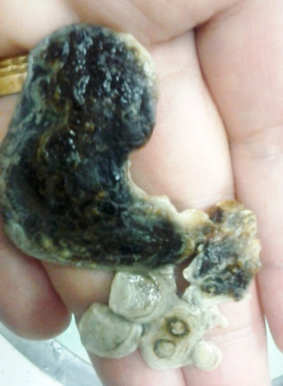 |  |  |  |  |  |  |  |  |  |  |  |  |  |  |  |  |  |  |  |  |  |  |  |  |  |  |  |  |  |  |  |  |  |  |  |  |  |  |  |  |  | The eschar is composed of dead cancer cells, combined with red blood cells and various immune-related cells, (granulocytes, macrophages, neutrophils, etc.)  The deteriorating appendages on the bottom of this eschar are still there, but in a different form.
July 15, 23:44:25 |  |  |  |  | July 15, 23:44:53
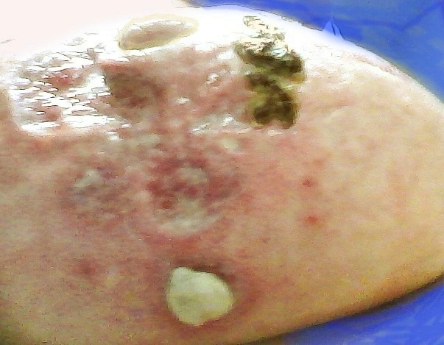 |  |  |  |  |  |  |  |  |  |  |  |  |  |  |  |  |  |  |  |  | 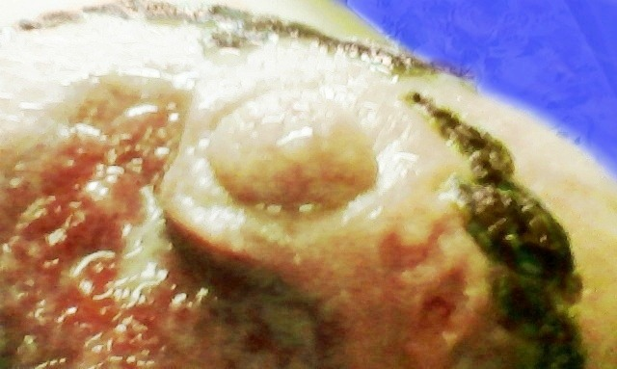
 |  |  |  |  |  |  |  |  |  |  |  |  |  |  |  |  |  |  |  |  | July 15, 23:48:30. There was no bleeding because a significant amount of healing had already taken place while the eschar was gradually separating from the tissue around it.
July 15, 23:46:44. The same strange little eschar at the bottom is still there.
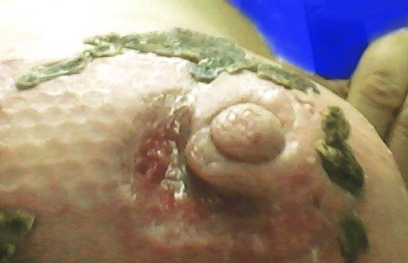 |  |  |  |  |  |  |  |  |  |  |  |  | 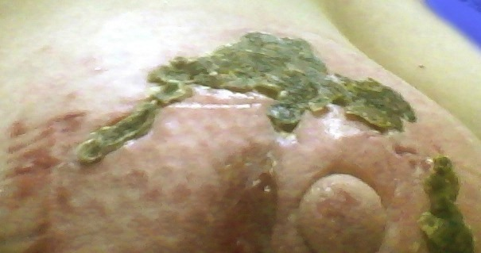
July 16, 21:57:25. The hole where an eschar has fallen out is called a “decavitation.” This decavitation is showing signs of healing, and will continue to do so until the hole is completely gone. |  |  |  |  |  |  |  |  |  |  |  |  |  |  |  |  |  |  |  |  | July 16, 21:58:24. In both of the above pictures, a small piece has fallen off on the right side, but the bigger piece is still there. See small indentations, or decavitations in the gap between eschar pieces.
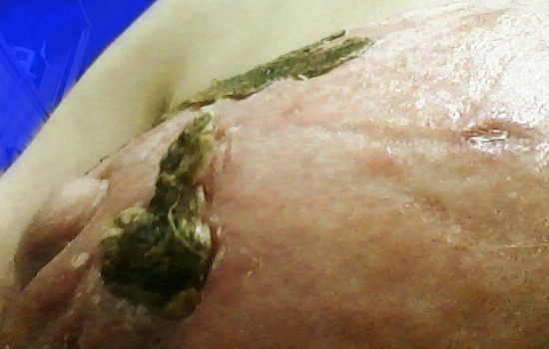 |  |  |  |  |  |  |  |  |  |  |  |  |  |  |  |  | 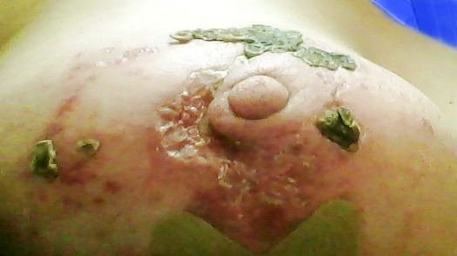
July 16, 21:58:14. An eschar chunk on the side opposite the cresent is getting ready to break off from the rest of the embedded eschar and fall off. |  |  |  |  |  |  |  |  |  |  |  |  |  |  |  |  | July 17, 21:57:18. On the left side of the picture is continued healing where the large eschar ejected, and on the right is continued chipping of what remains of the eschar there.
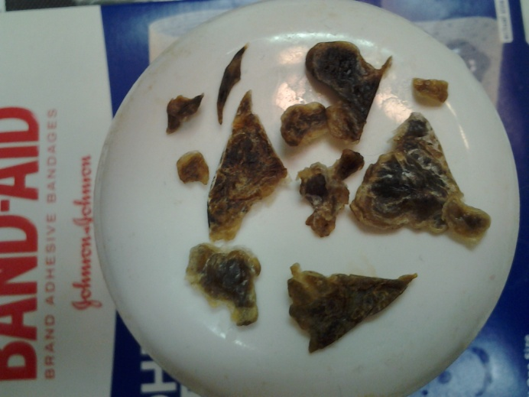 |  |  |  |  |  |  |  |  |  |  |  |  |  |  |  |  |  | 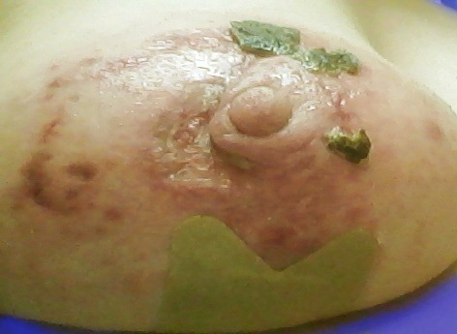
July 17, 22:04:47. Lots of pieces are detached, and either falling off, or I cut the loose parts off if they were loose at one end, and attached at the other end. |  |  |  |  |  |  |  |  |  | July 17, 22:05:44. Overview, showing continued healing of the crescent shape, and most of the other eschar surfaces are now gone. There is only a small piece remaining of the eschar on the right side of the picture.
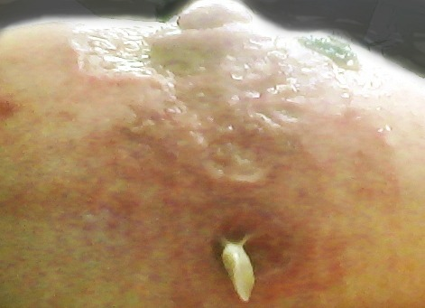 |  |  |  |  |  |  |  |  |  |  |  | 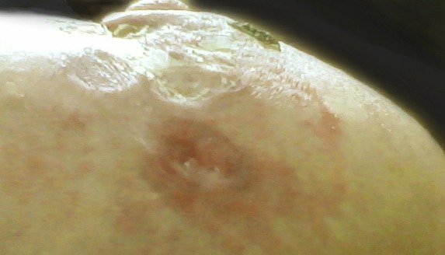
July 17, 22:03:30. The white protrusion above has changed back and forth between a slimy-looking gray-white and a black-to-brown eschar surface. You have seen it in many pictues already. Above, it is very pliable, and the next day, when exposed to the air for a while without a bandage, it finally dried up and fell off. |  |  |  |  |  |  |  |  |  |  |  | July 19, 01:06:16. This does not really count as an eschar ejection because it was only the surface that fell off. Nothing came out from the inside. Later, it formed another small eschar because there was still something inside that needed to come out. This is just another one of the strange things that can happen as the body seeks to eject things that do not belong on the inside. Keep watching for this spot in the next several pages.
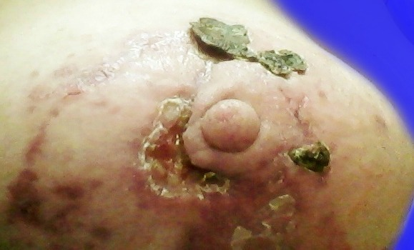 |  |  |  |  |  |  |  |  |  |  |  |  |  |  |  |  |  |  |  |  |  |  |  |  |  |  |  |  |  |  |  |  |  |  |  |  | 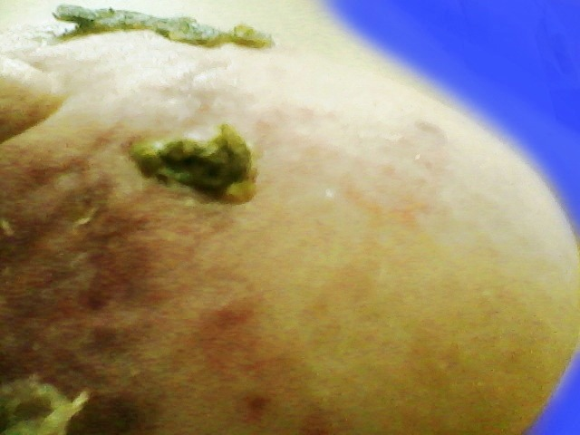
July 20, 00:29:24. Much more fill-in of the crescent shape. The line of scar tissue from the crescent up to the eschar at the top is where there were small decavitations under the eschar surface. See July 12, 00:29:34. |  |  |  |  |  |  | July 21, 11:43:45. This side of the breast apears to be immensely swollen, but you can see from the other pictures on this page, as the hole on the opposite side of the nipple fills in, it is shrinking and pulling the nipple off to one side, thus creating the distortion that you see above. As the scar tissue relaxes and dissipates, the distortion goes away.
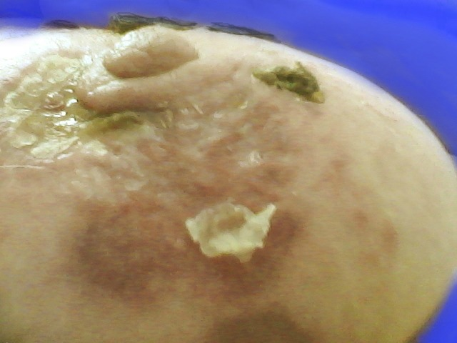 |  |  |  |  |  |  |  |  |  |  |  |  |  |  |  |  |  |  |  |  |  |  |  | 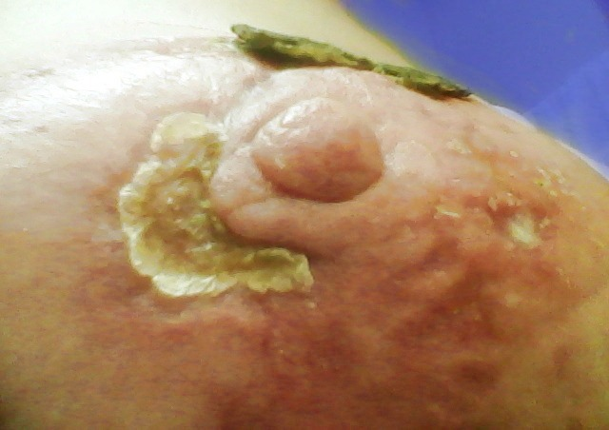
July 21, 11:44:01. In the healing process, the body creates little bits of tissue that look like small pieces of onion skin paper where the body is working on filling in a hole. |  |  |  |  |  |  |  |  |  |  |  |  |  |  |  |  |  |  |  |  |  |  |  | July 22, 21:21:16. The stubborn little eschar on the right side of the picture on the left has finally fallen off with only a small bit of debris behind it.
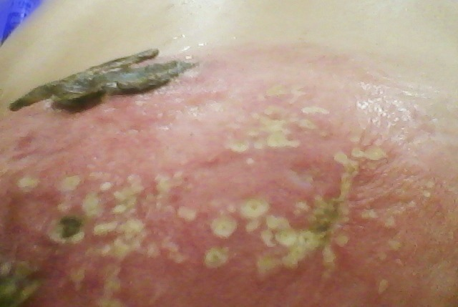 |  |  |  |  |  |  |  |  |  |  |  |  |  |  |  |  |  |  |  |  |  |  |  |  |  |  |  |  |  |  |  |  |  |  |  | July 23, 22:58:16. While the eschars at the top progressed toward ejection, I started a second round of salve on the area opposite the crescent-shaped eschar mass because that area did not get as much attention with salve before I stopped the salve for a while because of dealing with a large ejection. Here we are starting over with the escharization process.
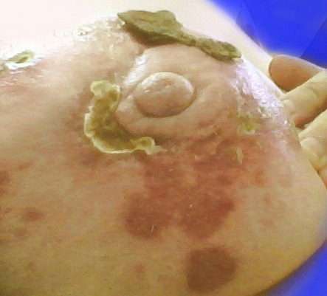 |  |  |  |  |  |  |  |  |  |  |  |  |  |  |  |  | 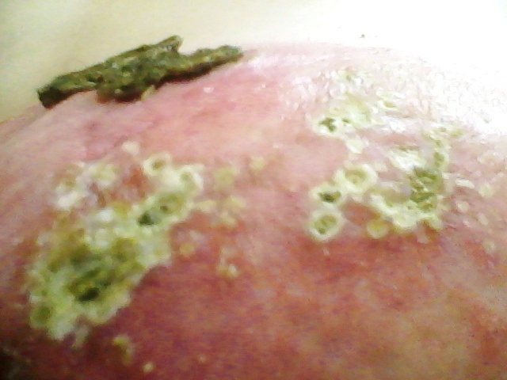
July 24, 12:03:41. You can see a new eschar on the far left side of the picture above in response to a new round of salve there. When an eschar is ejected, you see hyperpigmentation (the dark purple spots) that gradually fade away in the next several months. |  |  |  |  |  |  |  |  |  |  |  |  |  |  |  |  |  |  |  |  |  |  |  |  |  |  |  |  |  |  |  |  |  |  |  |  |  |  |  |  |  |  |  | July 25, 13:03:53. Increased escharization in response to salve on the side opposite the original eschar mass.
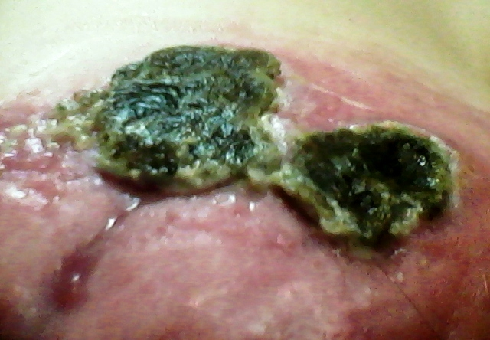 |  |  |  |  |  |  |  |  |  |  |  |  |  |  |  |  |  |  |  |  | 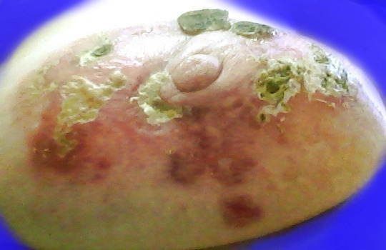
July 27, 00:14:46. These eschars are very loose, and are having a lot of seepage as they approach ejection. They used to feel very stiff, but now they feel like wet cardboard. |  |  |  |  |  |  |  |  |  |  |  |  |  |  |  |  |  |  |  |  |  |  |  |  |  |  |  |  |  |  |  |  |  |  |  |  |  |  |  |  |  |  | July 28, 12:40:54. New escharization on both sides.
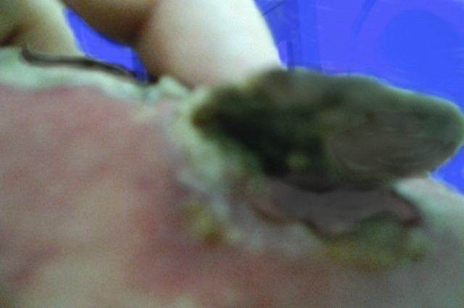 |  |  |  |  |  |  |  |  |  |  |  |  |  |  |  |  |  |  |  |  |  |  |  |  |  |  |  |  |  |  |  |  |  |  |  |  |  |  |  |  | July 28, 22:10:09, The eschar on the right side of the picture was so loose, it looked ready to fall out, but strangely, like the story of the tortoise and the hare, after it was bandaged again, it settled in for several more days, and the one on the left came out first.

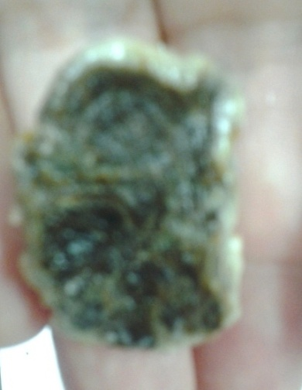 |  | 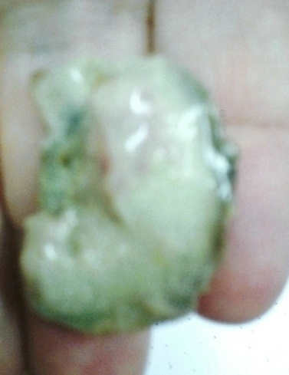 |  |  |  |  |  |  |  | 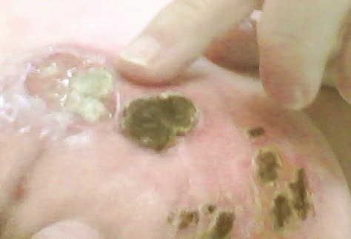
July 29, 09:51:18. The eschar surface is intact. | July 29, 09:50:53. The debris behind the eschar breaks apart, and most of it comes out, but some is left in the decavitation. |  |  |  |  |  |  |  |  |  |  |  |  |  | July 29, 09:55:40. A small amount of debris is still inside the decavitation.
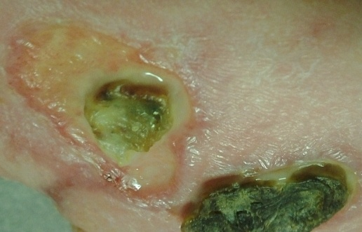 |  |  |  |  |  | 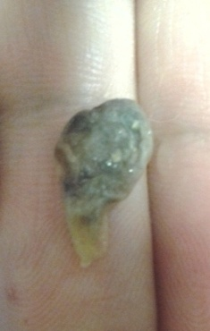 |  |  |  |  |  |  | 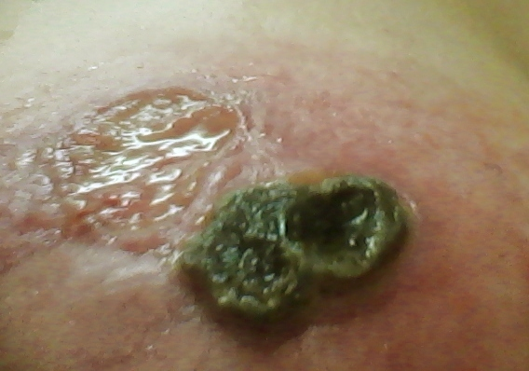
July 29, 23:04:06. The remaining piece of debris turned dark, and the body spontaneously produced a heavy amount of fluid, which probably helped to wash it out. |  |  |  |  |  | July 30, 00:26:03. After midnight, it finally fell out. |  |  |  |  |  |  | July 30, 00:28:00. There is a clean decavitation where the debris that had broken off from the eschar is finally completely gone.
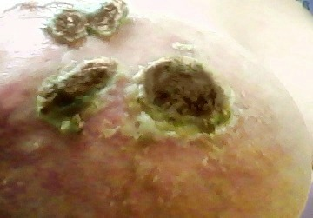 |  |  |  |  |  |  |  |  | 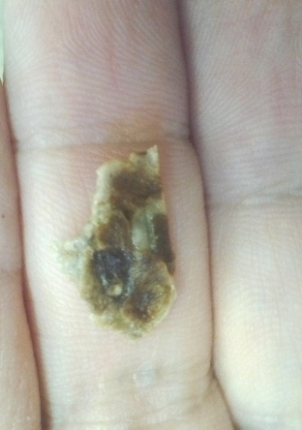 |  |  |  |  |  |  | 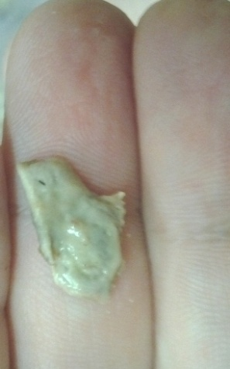
July 31, 16:54:47. The ejection of a small eschar in the middle of the picture in between two larger ones. |  |  |  |  |  |  |  |  | July 31, 16:57:22 & 16:57:44. A small amount of debris is attached to the back of the eschar.
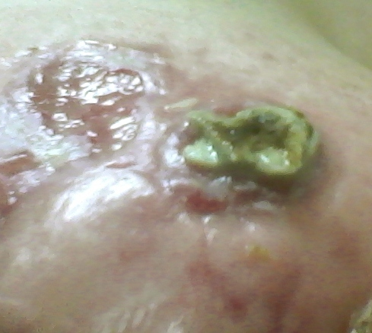 |  |  |  |  | 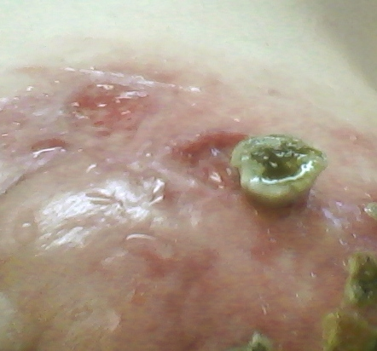 |  |  |  |  |  |  |  |  | 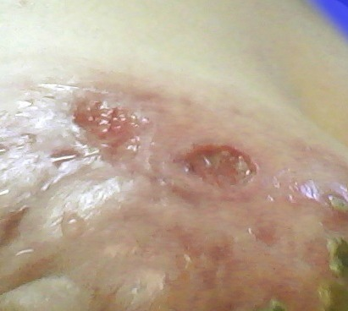
July 31, 22:27:57. This remaining eschar also was flooded with yellowish fluid the last 2-3 days before ejection. |  |  |  | August 2, 16:55:30. This eschar surface was almost completely worn away. The entire eschar was now attached only by a tiny thread of tissue. |  |  |  |  |  |  |  |  |  |  |  | August 2, 16:57:59. I finally clipped the thread, and released the eschar.
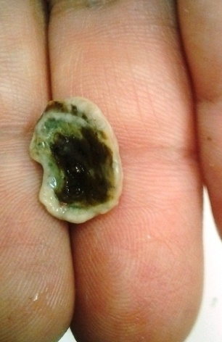 |  |  | 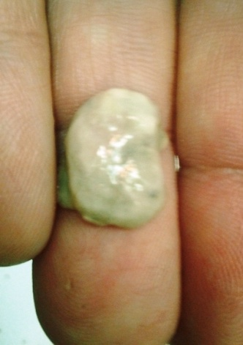 |  |  |  |  |  |  |  |  | 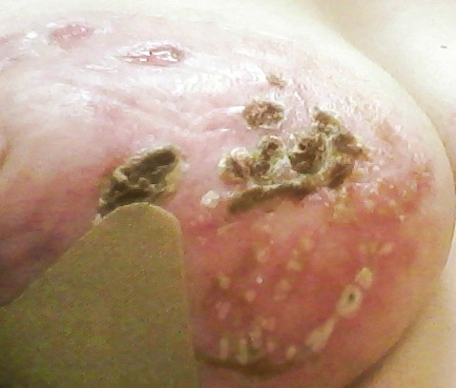
August 2, 16:58:19. All of the original crop of eschars is now gone. |  |  | August 2, 16:58:31. |  |  |  | August 3, 23:51:35. In this cluster of eschars that developed after starting the salve applications again, only a couple of small pieces have now fallen off.
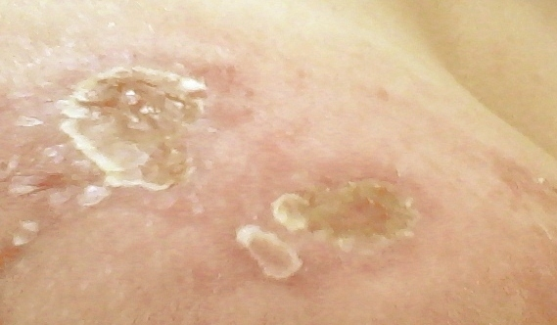 |  |  |  |  |  |  |  |  |  |  | 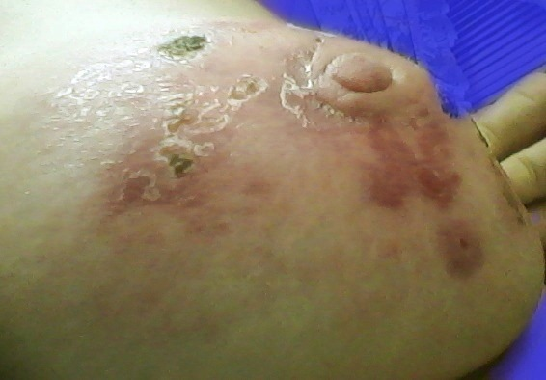
August 4, 23:33:199. The holes are now covered with tissue and beginning to fill in. |  |  |  |  |  |  |  | August 4, 23:31:23. What used to be a hole, where the huge crescent-shaped eschar mass fell out, is now a tiny piece of tissue over the filled-in hole.

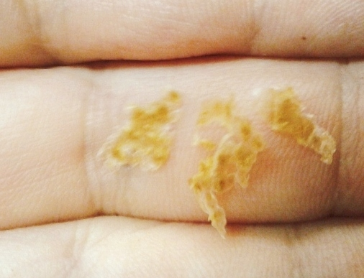 |  |  |  |  |  |  |  |  |  |  |  |  |  | 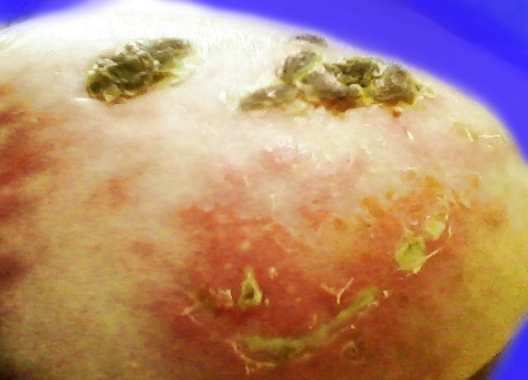
August 5, 00:13:37. There was loose peeling skin like a layer of epidermis that was turning brown. Under it was the red part in the next picture.
August 5, 00:14:37. (Right side, above) There is something amazing about what is happening here. Before this, every other place where escharization occurred, it was directly in response to application of salve. In the above picture, I had applied salve earlier, which caused the cluster of eschars up above, but in the part that is red and has a string of eschars going across, I had NOT put any salve there. The salve is like a smart bomb. It “knows” where to go. Obviously, there was a pocket of cancer there, and the salve found it. Also see similar picture from August 3. After this, I started applying salve to this area. See what happened next.
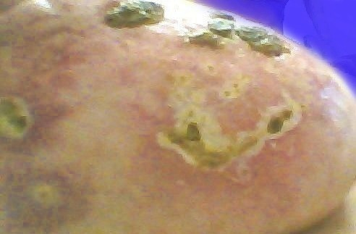 |  |  |  |  |  |  |  |  |  |  |  |  |  |  |  |  |  | 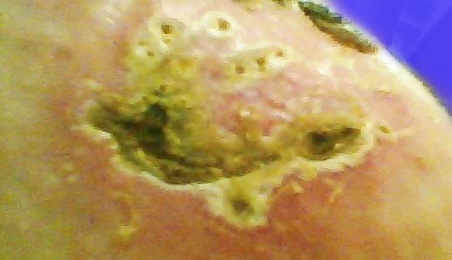
August 6, 10:07:05. The eschar cluster up above is still there, but once I applied salve to the area below, escharization was immediate. |  |  |  |  |  |  |  |  |  |  |  |  |  |  |  |  |  | August 7, 19:18:21. The growth of the eschar mass was very fast. See how the escharization follows the pattern of the redness in the August 3 & 5 pictures.
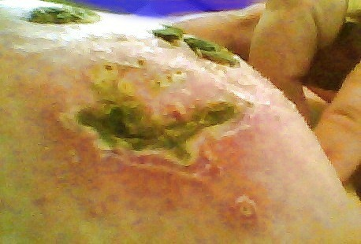 |  |  |  |  |  |  |  |  |  |  |  |  |  |  |  |  |  |  |  |  | 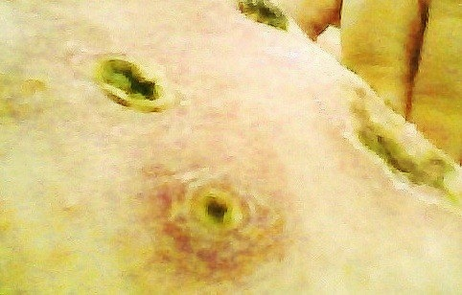
August 8, 10:30:15. New escharization continues while the eschar cluster above it is deteriorating and falling apart. |  |  | August 8, 10:30:07. In addition to the eschar on the right, the two spots directly under the nipple are still cancer hot spots. The top one was attached to the first eschar mass. See July 15, 23:46:44. The bottom one came apart when the previous white surface fell off. See picture from July 19, 01:06:16.
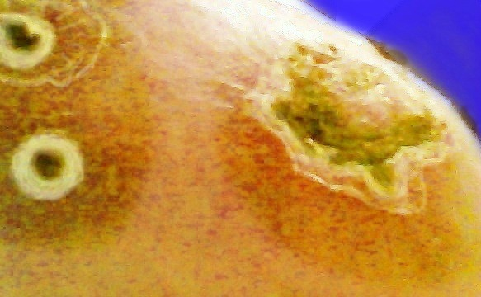 |  |  |  |  |  |  |  |  |  |  |  |  |  |  |  |  |  |  |  |  |  |  |  |  |  |  |  |  | 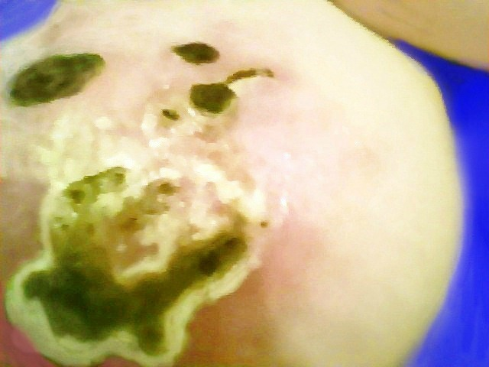
August 8, 20:45:12. Notice the two eschars below the nipple. Both surfaces look ready to fall off. In the lower one, it looks like pustular debris is pushing outward all around. |  |  |  |  |  |  |  |  |  |  |  |  |  |  |  |  |  |  |  |  |  |  |  |  | August 9, 12:30:09. In response to more salve, even more new eschars are forming. See the new clusters of yellow spots above the greenish-brown eschar mass.
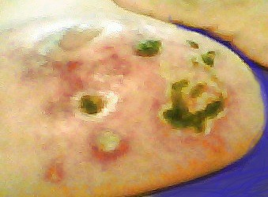 |  |  |  |  |  |  |  |  |  |  |  |  |  |  |  |  |  |  |  |  |  |  | 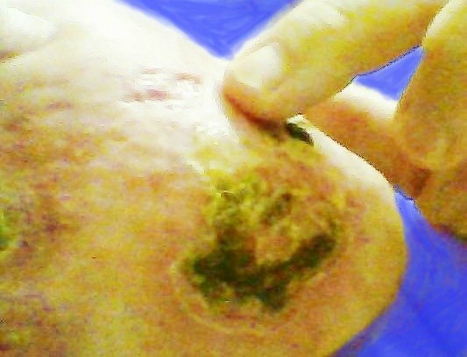
August 9, 20:47:00. In the lower of the two spots under the nipple, the eschar surface has fallen off, (for the second time) and pustular debris is exposed and being ejected. This was my only eschar in which the pustular debris was not collected in a little pocket or sac behind the eschar surface. It was just loose, and came out a little bit at a time over about a 10-day period. |  |  |  |  |  |  |  |  |  |  |  |  |  |  |  |  |  |  |  |  |  |  |  |  |  |  |  |  |  |  |  |  |  |  |  | August 10, 17:06:25. Where my finger is pointing, the eschar in the previous picture is now gone. The skin is beginning to peel around the new eschar mass.
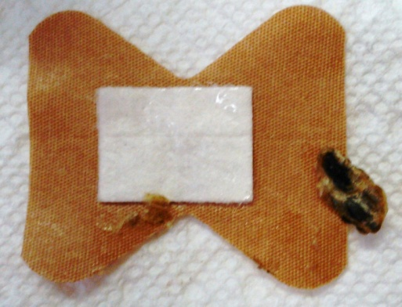 |  |  |  | 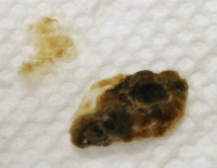  August 10, 17:05:15.  Nothing on the back of this one. |  |  |  |  |  |  |  |  |  |  |  |  |  |  |  |  |  |  |  |  |  |  |  | 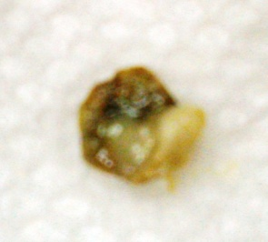  August 10, 17:17:20 |  |  |  |  |  |  |  |  |  | The one that was below my finger in the picture above fell out later, during a peroxide bath. For a small eschar, this one took with it a fairly significant amount of attached debris.
August 10, 17:05:00. Sometimes an eschar surface works loose, and comes off easily. Even if it does not have visible debris behind it, the surface itself contains red blood cells, dead cancer cells, and immune system “soldiers” that have either gotten killed in the fight or have survived the fight and have dragged dead cancer cells to the surface. When eschars deteriorate and fall off, some are just scabby material with little or nothing attached, and others carry pockets of pustular debris attached to the back.
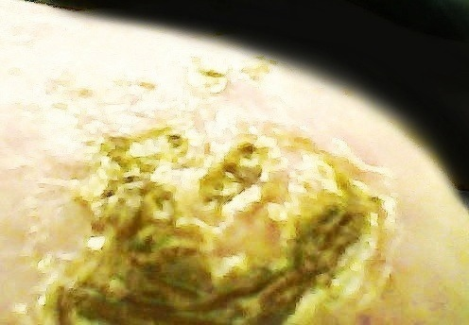 |  |  |  |  |  |  |  |  |  |  |  |  |  |  |  |  |  |  |  |  |  | 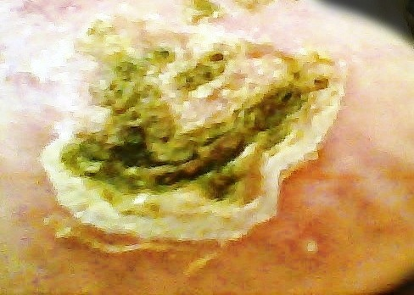
August 10, 23:29:37. This must be an expensive designer surface with an unusual color — olive green instead of plain black or brown, three-dimensional texture, and a fancy lace edge. |  |  |  |  |  |  |  |  |  |  |  |  |  |  |  |  |  |  |  |  |  |  |  |  | August 12, 12:32:11. This eschar is showing signs of preparing for separation. The skin is peeling more and is turning red under the eschar edge.
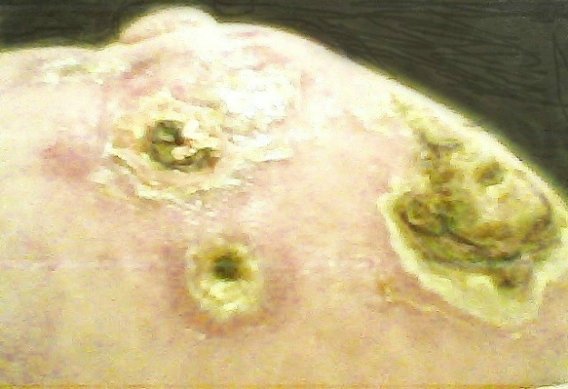 |  |  |  |  |  |  |  |  |  |  |  | 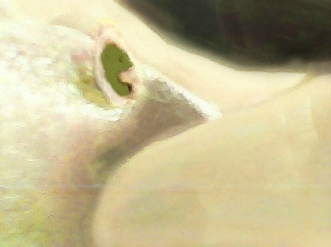 |  |  |  |  |  |  |  |  |  |  |  |  |  |  |  |  |  |  |  |  |  |  |  |  |  |  | 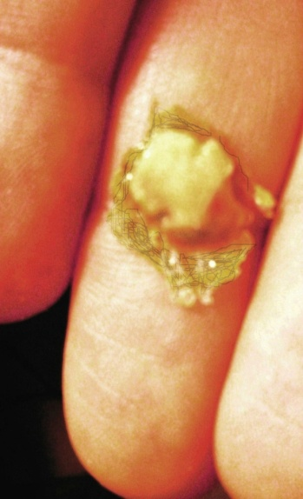
August 12, 22:16:38. The top eschar right below the nipple has very rough loose edges. The dark green color with the yellowish white trim looks like the eschar mass on the right. |  |  |  |  |  |  |  |  |  |  |  |  |  |  |  | August 12, 22:23:45. I pressed in on this spot a little bit. The black spot is just the shadow of my finger. |  |  |  |  |  |  |  |  |  |  |  |  |  |  |  |  |  |  |  |  | August 12, 22:24:27. Out popped the thin eschar surface with a pocket of debris behind it.
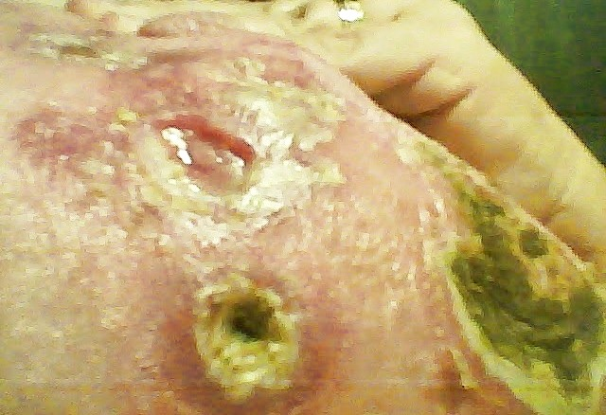 |  |  |  |  |  |  |  |  |  |  |  |  |  |  |  |  |  |  |  |  |  | 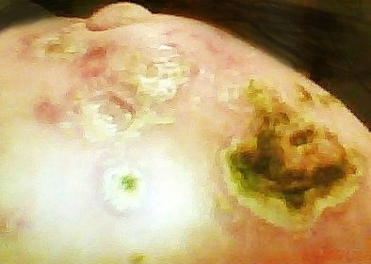
August 12, 22:25:48. A small amount of the debris separated and remained inside the decavita-tion, but came out completely within a few hours. |  |  |  |  |  | August 12:22:29:30. Near the top of the picture, you can see the debris that split apart and some of it remained in the hole. Below that, I shined a small flashlight inside the smaller hole. Nothing appeared to be in there except the same material that is on the outside edge.
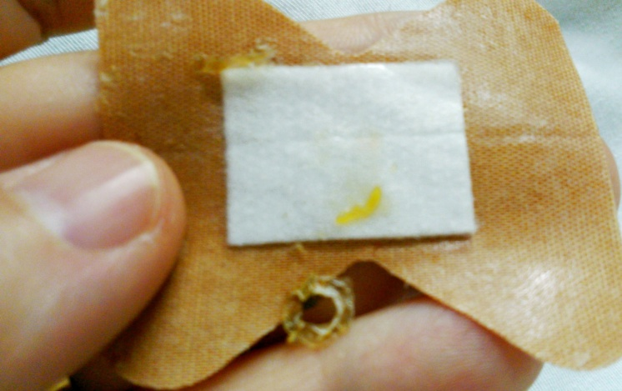 |  |  |  |  |  |  |  |  |  |  |  |  |  |  |  |  |  |  |  |  | 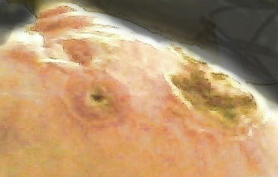
August 12, 23:14:02. I put a band-aid over the ejection site, and then tried to remove it carefully in order to reposition it, so as not to cover the edge of the hole below it, but the donut-shaped edge still got stuck to the band-aid, and came off. |  |  |  |  |  |  |  |  |  |  | August 13, 11:37:16. Near the top of the picture, the decavitation is well cleaned out, with a string-like piece of tissue coming from the middle. The remaining debris simply came loose and fell out without having to go through the extra secretion of fluid that occurred earlier. (See pictures from July 29.) The hole below it still has a “lining” on the inside.
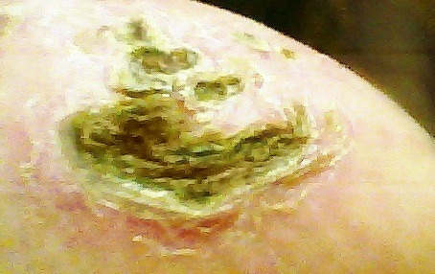 |  |  |  |  |  |  |  |  |  |  |  |  |  |  |  |  |  |  |  |  |  |  |  |  | 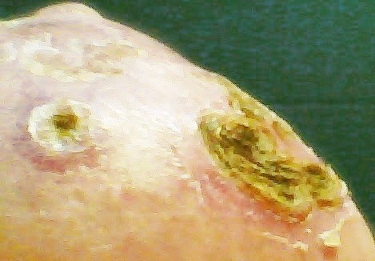
August 14, 22:31:04. This eschar mass is starting to break apart with two cracks that come together at a right angle. The surface is getting worn down, and most of the light-colored edge has fallen off. Only a tiny remnant remains. |  |  |  |  |  |  |  |  |  |  |  |  |  |  |  |  |  |  |  |  |  |  | August 15, 11:28:59. The spot near the nipple where the eschar fell out on August 12 is covered over with new tissue. The eschar mass on the right side of the picture is breaking apart more, and almost all of the rough green surface has worn off.
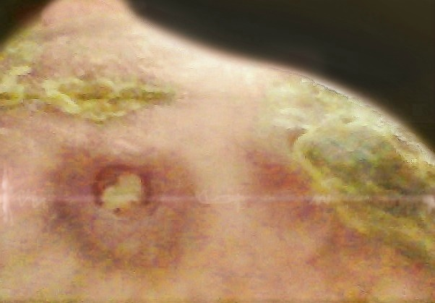 |  |  |  |  |  |  |  | 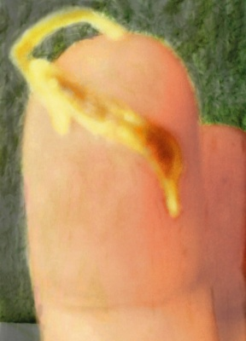 |  |  |  |  |  |  |  |  |  |  |  |  |  |  |  |  |  |  |  |  |  |  |  | 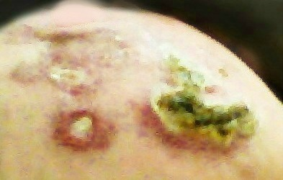
August 16, 12:50:27. There is still a remnant of a yellowish-brown edge around the eschar mass. Also the hole where the donut-shaped edge came off is still ejecting white debris that probably contains cancer cells. |  |  |  |  |  |  |  |  |  | August 16, 12:54:11. I touched what was left of the yellowish-brown edge, and part of it fell off. |  |  |  |  |  |  |  |  |  |  |  |  |  |  |  |  |  |  |  |  |  |  | August 16, 21:36:54. The lower part of the eschar mass on the right has lost most of its edge. The open decavitation to the left is still putting out debris. This is like an ejection in slow motion.
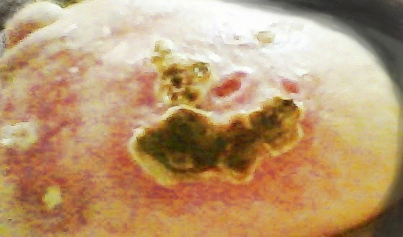 |  |  |  |  |  |  |  |  |  |  |  |  |  |  |  |  |  |  |  |  |  |  | 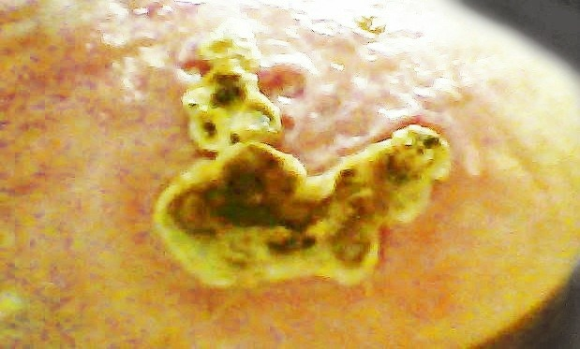
August 16, 21:38:20 |  |  |  |  |  |  |  |  |  |  |  |  |  |  |  |  |  |  |  |  |  |  | August 17, 23:42:43
The rough eschar surface has worn away and is gone. The second picture above is about 26 hours later than the first one. The first one has two small decavitations, or indentations in the skin, where small pieces of eschars have fallen out. In the second picture, both of them have been filled in, but there is one new little indentation beside the small eschar mass, where one little piece has fallen off.
In the picture on the left, notice the redness around the bigger eschar mass as it pushes toward separation. Then in the picture on the right, there is noticeable separation of the edges around the right side, and the redness has decreased considerably.
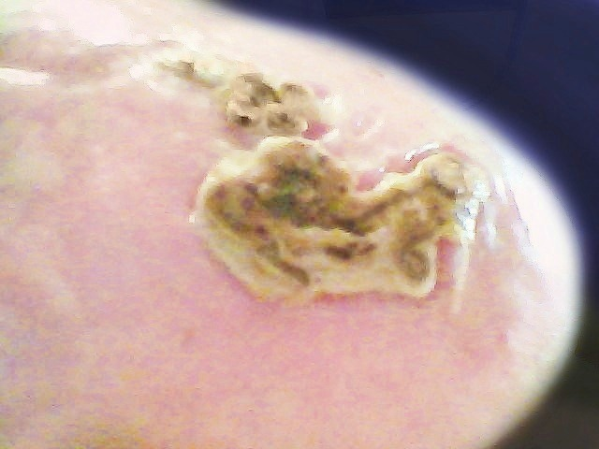 |  |  |  |  |  |  |  |  |  |  |  |  |  |  |  |  |  |  |  | 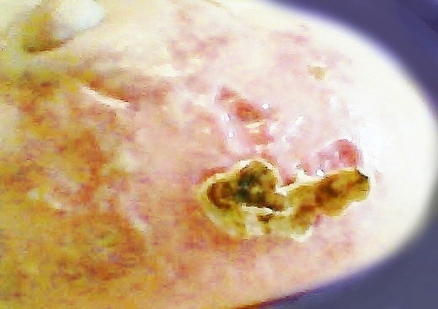
August 18, 12:03:57. You can see holes where some small pieces have fallen out, and the bigger pieces are very loose. |  |  |  |  |  |  |  |  | August 18, 12:08:41. The smaller eschar mass has just fallen out. Behind the remaining eschar mass are little cone-shape pieces of white debris that are being pulled out like nails from the tissue behind them.
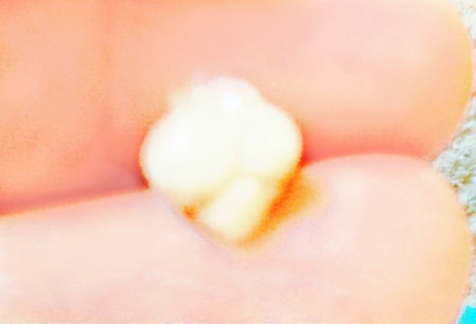 |  |  |  |  | 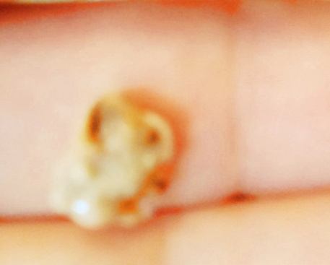 |  |  |  |  |  |  |  |  |  |  |  |  |  |  |  |  |  |  |  |  |  |  |  |  |  |  |  |  | 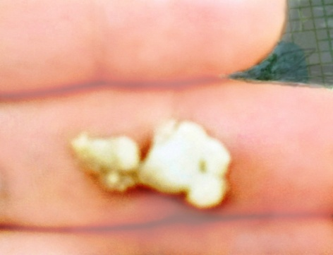
August 18, 12:05:30. This is the first eschar I have seen where it was divided into lobes like a four-leaf clover, but where the edge of the top lobe looks blurred, it is broken, and part of it is bent over toward the other side. |  |  |  |  |  |  |  |  |  | August 18, 12:06:41. The front side looks blurred because of the broken part that is folded over onto this side, and debris is spilling out. |  |  |  |  |  |  |  |  |  |  |  |  |  |  |  |  |  |  |  |  |  |  |  | August 18, 12:07:10. I unfolded the part that was folded over. You can recognize this extra piece by going back to the top of this page and looking at this eschar before it ejected.
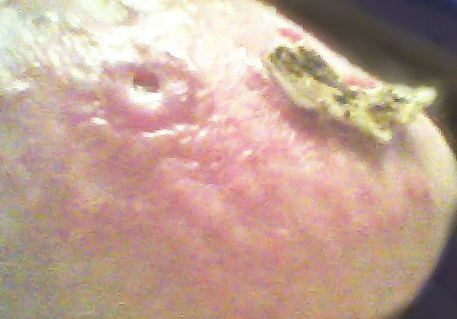 |  |  |  |  |  |  |  |  |  |  |  |  |  |  |  |  | 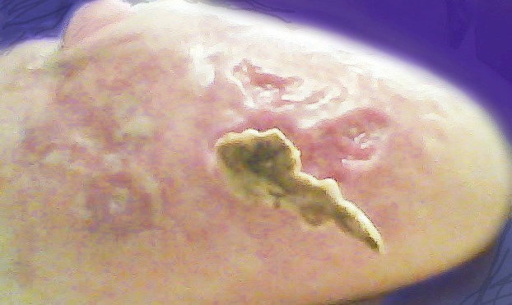
August 18, 12:20:20. |  |  |  |  |  |  |  |  |  |  |  |  |  |  |  |  | August 18, 19:12:27.
Finally, the hole in the spot under the nipple appears to have cleared out all or most of the pustular debris that has been in the process of being slowly ejected over a period about 9-10 days.
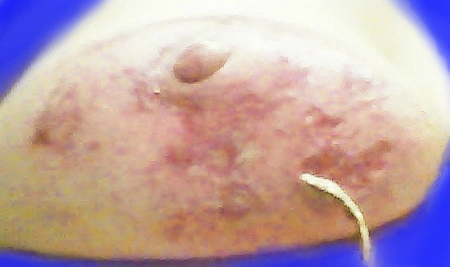 |  |  |  |  |  |  |  |  |  |  |  |  |  |  |  |  |  |  | 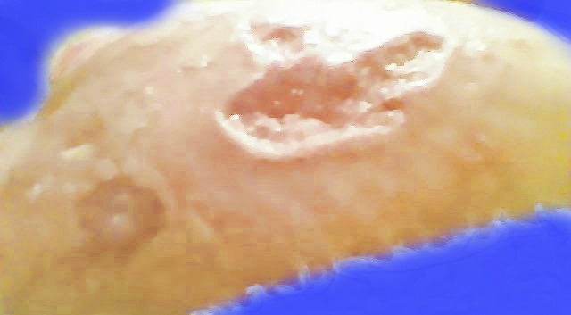
August 18, 22:55:50. Notice the thickness of the left side of this eschar, compared to the right side. |  |  |  |  |  |  |  |  |  |  |  |  |  |  |  |  |  |  | August 18, 23:41:26. Notice the depth of the opening, or decavitation, on the left side, compared to the right side.
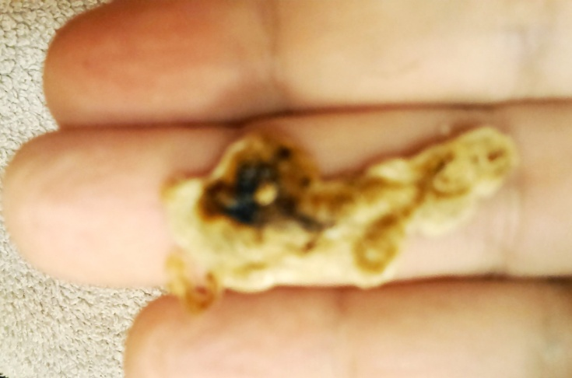 |  |  |  |  |  |  |  |  |  |  |  |  |  |  |  |  |  |  |  |  |  | 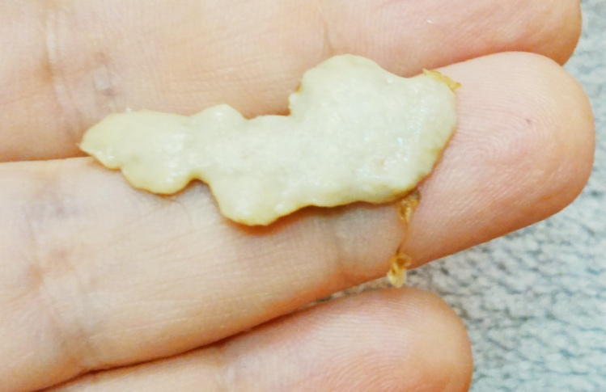
August 18, 23:38:58. This was my second largest eschar ejection. Compare again to the pattern of redness in the pictures from August 3 and August 5. You can still see the same shape in the ejected eschar. Also notice the little golden-brown string hanging from the left side of the eschar mass. It was the final thing holding the eschar in place. This is the only one of my eschars that had a string that acted like a piece of tape holding an eschar mass to the skin. |  |  |  |  |  |  |  |  |  |  |  |  |  |  |  |  |  |  |  |  |  |  |  |  |  |  |  |  |  |  | August 18, 23:39:36. When the salve was applied to the area up above this, and formed a small eschar cluster, it is no wonder that the salve was drawn to the area below the cluster, with such a large pocket of cancer cells there. The same string that you saw in the previous picture is now hanging from the right side since the ejected eschar is turned over.
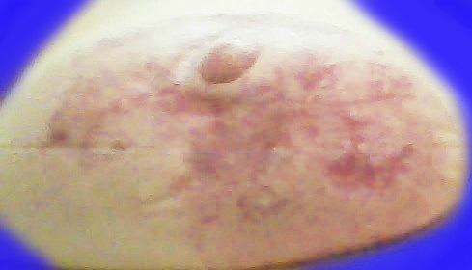 |  |  |  |  |  |  |  |  |  |  |  |  |  |  |  |  |  |  |  |  |  |  | 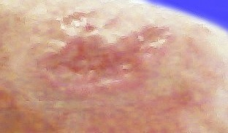
August 19, 20:50:17. Overview |  | August 20, 09:36:18. More close-up view of eschar ejection site, which is much deeper on the left side of the picture than on the right side.
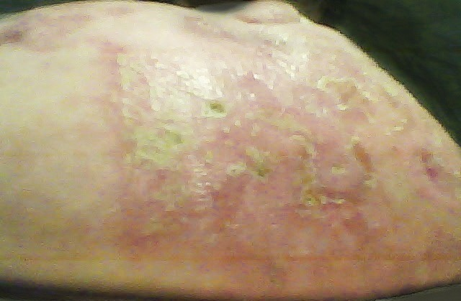 |  |  |  |  |  |  |  |  |  |  |  |  |  |  | 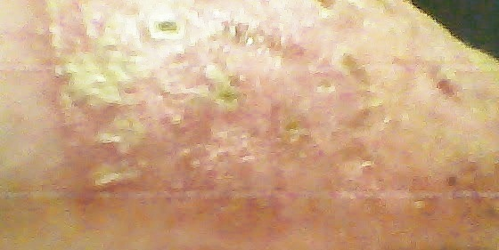
August 21, 22:45:13. On August 19 and 20, I re-applied salve to the area below the nipple in the front because of some rough spots and places where there appeared to be small areas of debris that had not been completely ejected. Here we are starting another round of escharization. The purpose is to help discover whether there is anything else inside that needs to come out. |  |  |  |  |  |  |  |  |  |  |  |  |  |  |  |  |  |  |  |  |  |  |  |  |  |  |  |  |  |  |  |  |  |  | August 22, 21:32:58. Here you see some of the new small eschars as a result of recent salve applications. Compared to early and mid-June, this response to the salve is minimal.
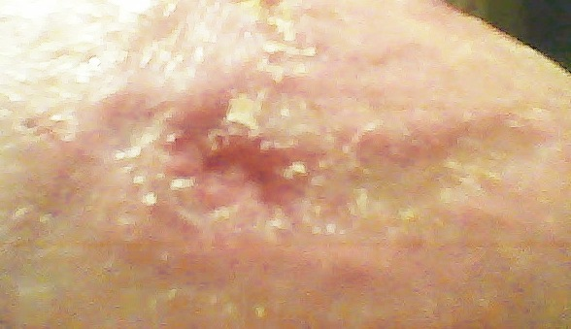 |  |  |  |  |  |  |  |  |  |  |  |  |  |  |  |  |  |  |  |  |  | 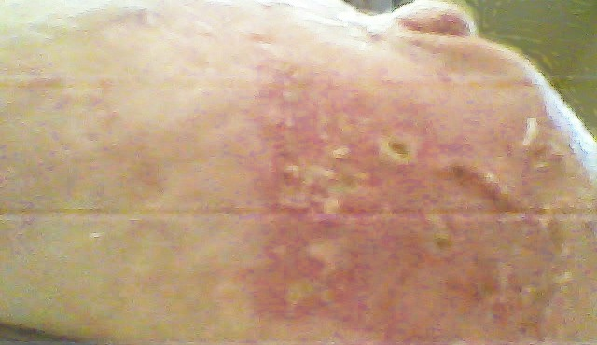
August 22, 21:33:53. Continued healing at the site of the most recent eschar ejection. | August 23, 11:40:21. On the nights of August 22 and 23, I applied salve to the two sides of the breast in areas furthest away from the nipple, where there had not been previous applications of salve. I wanted to see whether there was anything there that would cause a reaction. As you can see above, nothing happened, but you can still see mild escharization at the site of the recent salve application in center front.
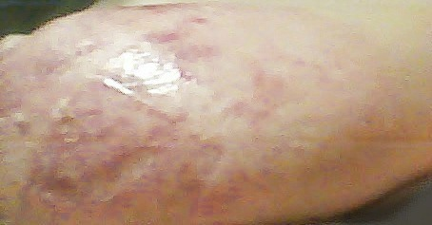 |  |  |  |  |  |  |  |  |  |  |  |  |  |  |  |  |  |  |  |  |  |  |  |  |  |  | 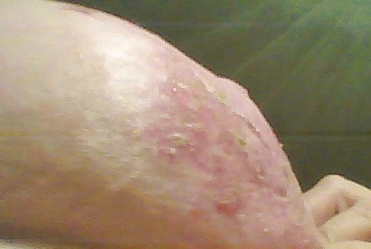
August 23, 23:13:27. This is the side toward the other breast, after salve has been applied the night before. You can see previous eschar marks, but nothing new except just a little bit of red color — no escharization at all. If there are no cancer cells there, nothing happens. |  |  |  |  |  |  |  |  |  |  |  |  |  |  |  |  |  |  |  | August 23, 23:14:11. This is the side of the breast toward my arm. I had applied salve the previous night, and the same thing happened as on the other side — NOTHING! The mild escharization that you see is the same as in the picture above. It developed in response to salve a few days earlier.
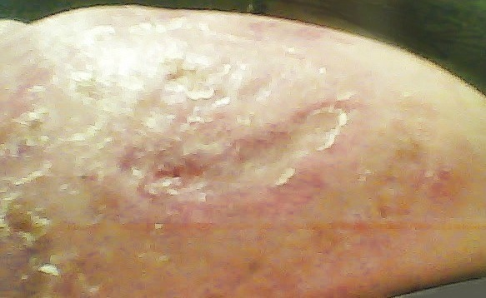 |  |  |  |  |  |  |  |  |  |  |  |  |  |  |  |  |  |  |  |  |  |  |  |  | 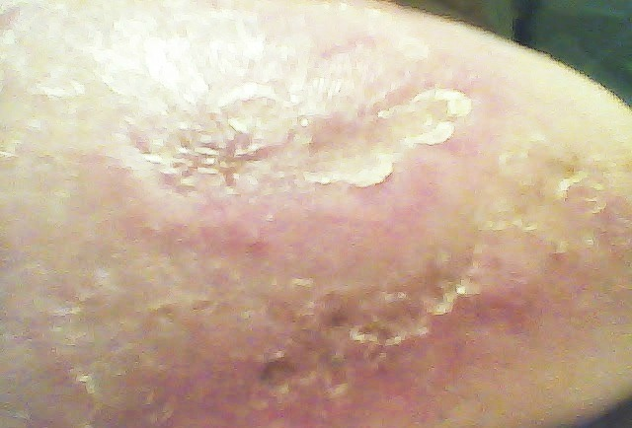
August 23, 23:15:29. The middle and right sides of the eschar ejection site are well covered with new tissue. The left side, however, still has more work to do on healing because the hole was deeper there. |  |  |  |  |  |  |  |  |  |  |  |  |  |  |  |  |  |  |  |  |  |  |  |  |  |  |  |  |  | August 24, 23:30:15. Even the deepest part of the opening is starting to be covered over with healing tissue.
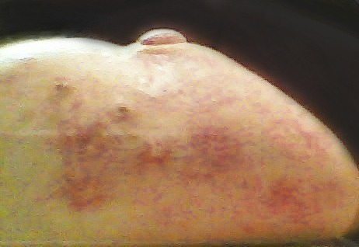 |  |  |  |  |  |  |  |  |  |  |  |  |  |  |  |  |  |  | 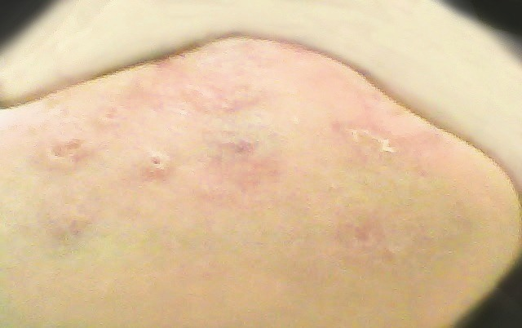
August 26, 21:41:16. Escharization at the site of the recent salve application in center front is decreasing, but there are still numerous small pockets of pustular debris. |  |  |  |  |  |  |  |  |  |  |  |  | August 28, 00:40:38. From the middle to the left of the picture above is what remains of the escharization from the recent salve application. On the far right is what is left of the healing tissue over the top of the eschar ejection site.
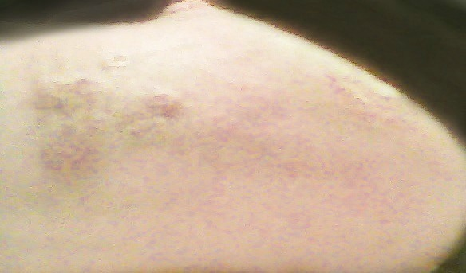 |  |  |  |  |  |  |  |  |  |  |  |  |  |  |  |  |  |  |  |  |  |  |  | 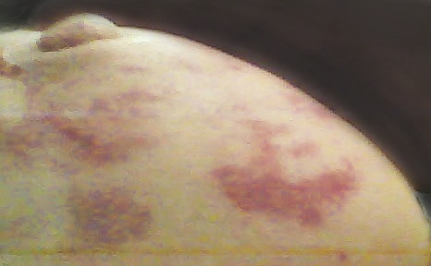
August 29, 12:15:09. Small rough spots remain, but no major disruptions. |  |  |  |  |  |  | August 31, 00:32:10. The site of the last eschar ejection is now smooth and healed over, leaving nothing but visible hyperpigmentation that will fade away as time goes by.
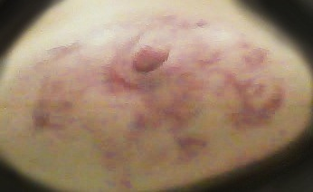 |  |  |  |  |  |  |  |  |  |  |  |  |  |  |  |  |  |  |  |  | 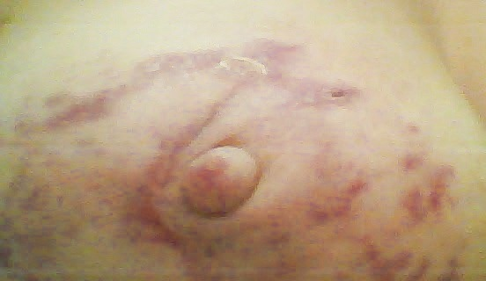
August 31, 00:31:22. Every dark purple spot represents an eschar that has been ejected somewhere along the way. |  |  |  |  |  |  |  |  |  |  |  |  |  | August 31, 00:31:49. The line of scar tissue from beside the nipple up to the ejection site at the top is still noticeable, but not as deep as it used to be.
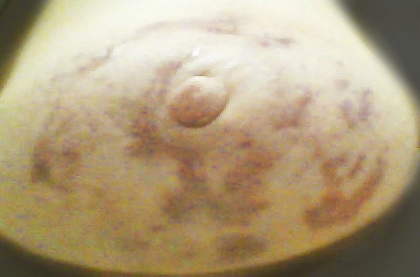 |  |  |  |  |  |  |  |  |  |  |  |  |  |  |  |  |  |  |  |  | 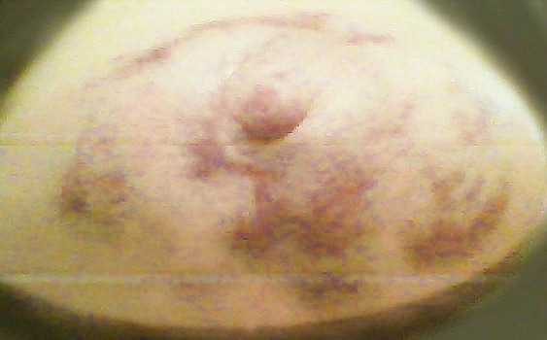
Sept. 16, 11;43:00. In the picture above, two weeks have gone by since the pictures above that one. The deep line of scar tissue running from the top of the crescent-shape eschar ejection to the ejection site at the top is now considerably less noticeable. |  |  |  |  |  |  |  |  |  |  |  |  |  |  |  |  |  |  |  |  |  |  |  |  |  | October 2, 11:22:31. This picture is very similar to the one before it, but you can see that the lines of distinction between the purple spots and the normal skin color are becoming blurred and the two colors are running together.
The next step is to continue working on inflammation and scar tissue so the breast will come as close as possible to regaining its normal contour.

Eschars Are Temporary;
Mastectomy Is Permanent!

The book, Heal Breast Cancer Naturally, is recommended reading. See the reference to the author, Dr. Veronique Desauliniers on the previous page. (http://BreastCancerConqueror.com/) In her book, she tells the story that when she was diagnosed with breast cancer, she already knew about escharotic salve, so she got on the internet, found some black salve, and ordered it. After weeks of using the salve and waiting for ejection, she had incomplete ejection of the tumor mass, and she got little support from her salve company. The outside healed over with the tumor still inside. She continued her other treatment strategies, but the tumor was still there. She finally came across a good salve company, where she got excellent customer support, the salve worked, and she had complete ejection of the tumor mass. Don’t just order any salve on the internet. They don’t all have the same results.

