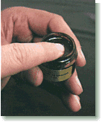

Mole Removal with Alpha Omega’s Bloodroot Paste
(submitted May 27, 2009 by “Kerri” – Last Name Withheld by Request)

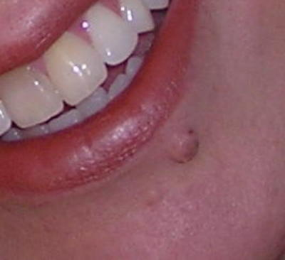
Left: Picture of me with my mole.

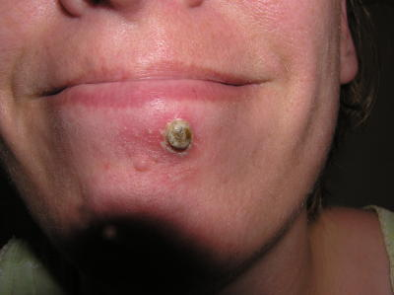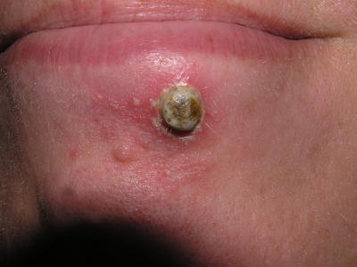

May 1, 2009: Second day after applying : exfoliated on day one, but not after. Applied paste 3x day. Stings when starts working.

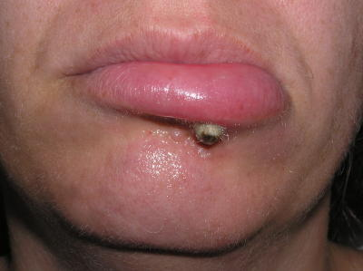
May 2, 2009: Day 3 -- My lip is quite swollen and painful: I am taking ibuprofen quite regularly, sleep difficult this nite.

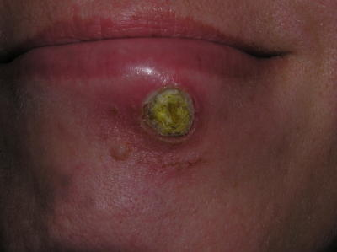
May 3, 2009 : The 4th day: there is no feeling in the mole itself: it is dead. My impatience to have to off pushes me to cut off the top half. I know, I know, but I was wanting change already!! Ps the shininess is from putting on a antibiotic ointment with a topical pain reliever…the surrounding area hurts.

On May 3 (Day 5): the eschar begins to separate from the healthy skin: I keep trying to help it along with tweezers but OUCH! I clean constantly with hydrogen peroxide and the above mentioned ointment.

May 4 and 5, 2009: Day 6 & 7: the eschar is pulling away at the top -- quite swollen around the area, and very ouchy.
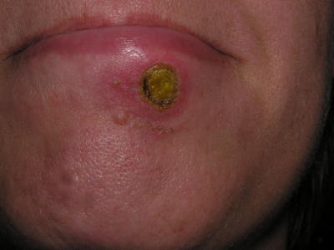
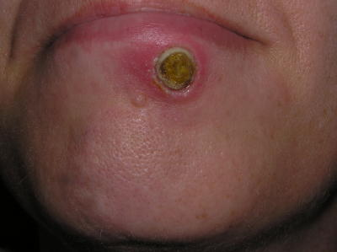
May 6 – May 8, 2009 : This pic taken in morning. By 3 p.m. eschar had fallen out: okay, okay with a little help at the end. And I paid for it too: with a big fat OUCH!

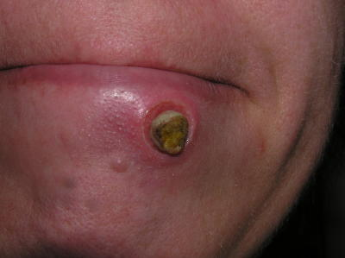

Empty hole in my face later that same day: the pain has stopped.

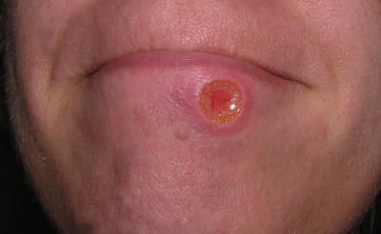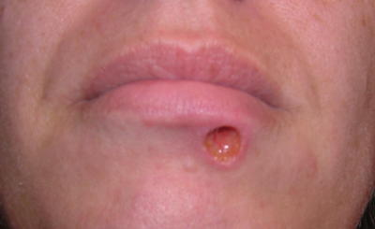

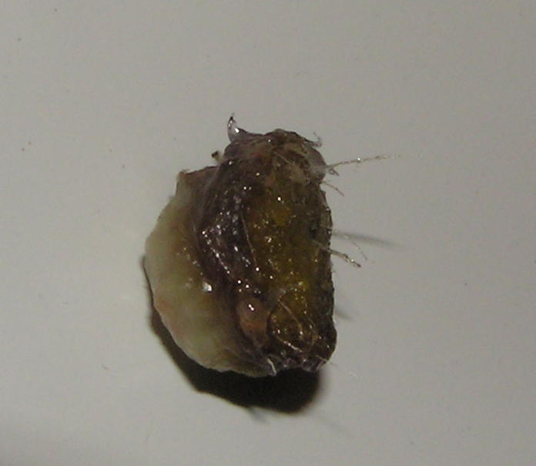
And here it is folks~the mole: yep this whole thing (well-minus the top half that I had cut off) ~really has a good yuck factor going on: gross. And see those hairs??!! I had to wax them suckers all the time!

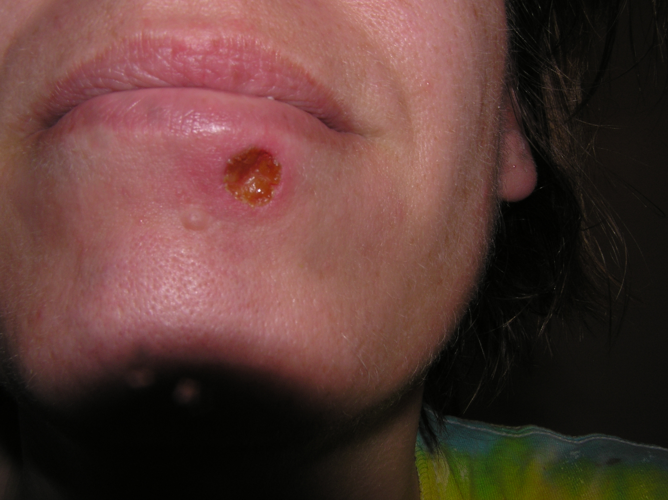
May 9, 2009: Day 11 -- New skin beginning to fill in the hole, a bit tender: woke me up when I laid on it.

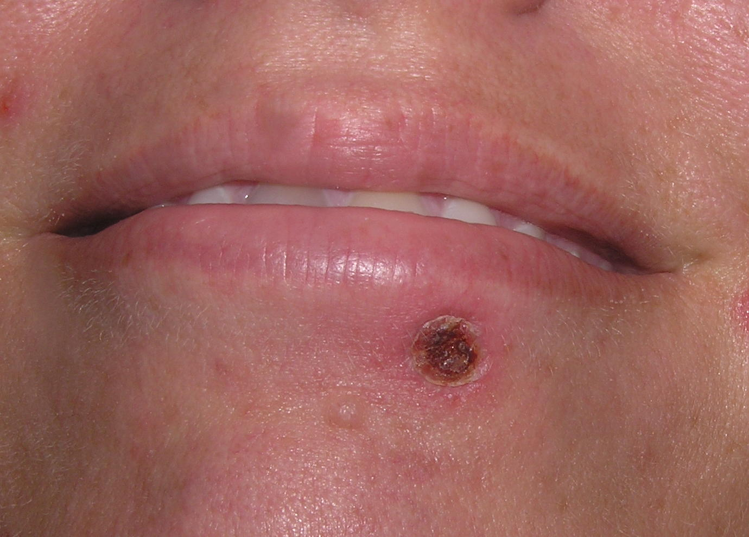
May 14, 2009 – Day 16

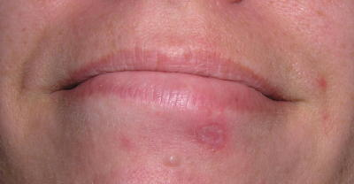

May 27, 2009 – Day 29 – It’s just a scar now, which a lot of folks who’ve used this have said will go away. If it does I’ll take a pic and send it in as well.

The end.

